Lockdown Bingo |  |  | Year 6  W/B 6/7/2020
Reading  For 20 minutes a day | Find out the meaning of the following words and write them; perjorative, emotive, logical, evidence, opinion  Writing X1 | Spell antonyms and synonyms for hot  Writing x 1 | Think of a number. Find a way to get to from there to 100 in 5 steps? 10 steps? 20 steps? Use each operation at least once.  Maths X1 | Draw a panda in 5 steps  https://www.bbc.co.uk/newsround/53063451  Creative x 1
Practice your Times tables | https://www.bbc.co.uk/bitesize/clips/zm3nvcw  Watch the video and make a list of the most important features of an argument.  Writing X1 | Imagine a world run by a different kind of creature. Draw a picture of a town and label it.  Creative X1 | Think of a person you think should be prime minister/in charge of the world.  Writing X1 | Look in the mirror and sketch a self-portrait. Then practice shading techniques to represent where the light changes.  Creative X1
Start with 2. How many times would you have to double it to get to 10,000. Make a prediction and test it.  Maths X1 | https://incoherency.co.uk/countdown /practice/#numbers  Visit this website and play Countdown Maths,  Maths X1 | https://incoherency.co.uk/  countdown/practice/#  Visit this website and play word Countdown | Look around your house for objects. Which object contains the most shapes? Make a bar chart of the results.  Maths x 1 | Make a Powerpoint about yourself to send to your Secondary School ahead of September. Include transitions and animations.  Creative X1
Write your own argument with the title ‘Should humans still rule the earth?’ Find reasons for and against  Writing x 1 | 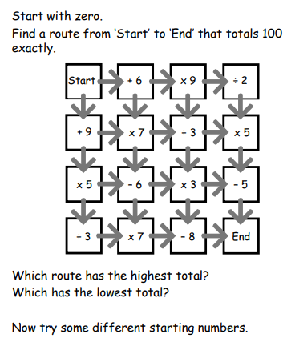  X Maths 1 | Use the random argument generator to create your own argument. Roll a dice 3 times to create an argument and find arguments for and against the statement.  X 1 Writing | How far can you run in  2 minutes? 4 minutes? 8 minutes? Make a prediction before you start and notice any patterns.  x1 Maths | Think of a number, double it.  Add four. Halve your answer.  Take away your original number.  The number you now have is 2.  Is this always true? Test it a few times.  X 1 Maths

