Year 6 – activities W/B – Term 6 Week 2
 | Maths | Topic/writing  (Victorians) | Creative
Video lessons | 1,234  Think of a two digit number. How many times must you subtract this 2 digit number from it, before you get to zero? You cannot go into minus numbers. | Write your ideal ending of ‘Oliver Twit; the Railway Child’. | Design and create a Victorian board game  Consider factors such as the workhouse and other factors such as education.
 | If you add up the answers in all the times tables (1-12) will the answer be bigger, or smaller, than 1,234? Predict and then investigate. | Notice there’s no stage directions in the script.
 | 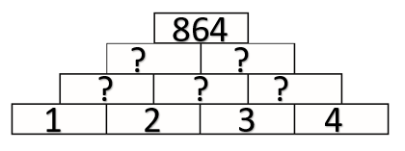  How have the numbers changed from 1, 2, 3 and 4 on the bottom layer of the pyramid changed to 864 on the top level? What calculations have taken place in between?  CLUE: Look at potential calculations between neighbouring numbers | Write a Film review for Oliver Twit. Consider bits you liked, bits you didn’t and what could be improved.
Non-video | Practice times tables 2-12 every day | Learn the common exception spellings using speed spell, rainbow words and other methods. | Design a stamp from the Victorian era with a picture of Queen Victoria on it.
 | Visit this website and play ‘Countdown’  http://happysoft.org.uk/countdown/numgame.php | Write an acrostic poem about the Victorians using your research from the previous grid. | Make up a Victorian test for your family.
 | Research the length of time Kings and Queens have reigned in England and create a bar chart based on the data. | 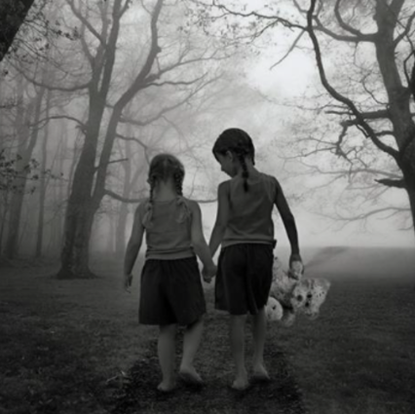  Here is a two picture of two girls (and a teddy) walking through a forest. Where are they going? Write a descriptive account of their journey. | Design your own toy for a Victorian child. Remember to make it simplistic (think about basic toys like a bat and ball).  Annotate your design.

