Name - |  |  | Date -
Lockdown Bingo |  |  |  | Year 6  W/B 29/6
Reading  For 20 minutes a day | Find out the meaning of these words, giving an example for each: simile, aliteration, onomatopoeia, metaphor, imagery  Writing X1 | Spell antonyms and synonyms for loud  Writing x 1 |  | The answer is 144. Find 5 ways to make it using each operation (+, -, x, ÷)  Maths X1 | Read the poem ‘The Sea’ by James Reeves. Make a storyboard with pictures for the poem  Creative x 1
Practice your Times tables | Write your own poem called ‘The sea’ using different features of poetry.  Writing X1 | Use your poem about the sea to create a model of the ocean as you have imagined it.  Creative X1 |  | Find 5 objects around your house and write a poem/story which involves all of them  Writing X1 | Paint an interesting picture of the sea, possibly including some elements you have drawn.  Creative X1
Goldfish cost £1.40. Angelfish cost £1.80. You spend £20 in total. How many of each do you buy?  Maths X1 | http://happysoft.org.uk/ countdown/numgame.php  Visit this website and play Countdown Maths,  Maths X1 | Read some poems and find examples of different features such as alliteration, metaphors, similes etc  Writing X1 |  | Next Wednesday is 1st July. How many days will there have there been so far this year? How many hours? How many minutes? How many seconds?!  Maths x 1 | Find a book you have read recently. Design a new front cover for it.  Creative X1
Go outside and find an element of nature which is interesting. Write a poem about it.  Writing x 1 | How many star jumps can you do in 1 minute? 2 minutes? 5 minutes? 10 minutes? Is there a link between the amount you complete in the respective times? (eg is the amount in 2 mins double the amount in 1?  X Maths 1/Physical | Write an acrostic poem about Mundella, using the letters M,U,N,D,E,L,L,A to start each line. Write about the school and your happy memories of it.  X 1 Writing |  | 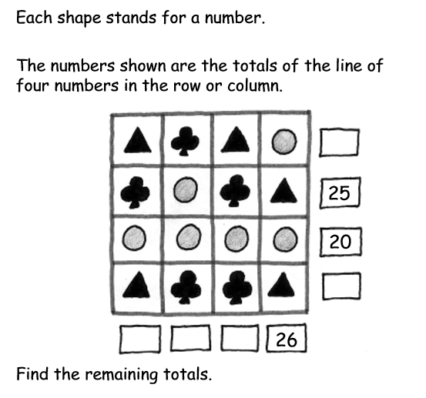  x1 Maths | Think of a number. Double it. Add 6. Half it. Subtract the number you started with. Is the answer always 3? Check with a variety of numbers.  X 1 Maths

