In Medieval times knights and soldiers used to paint designs on their shields, these were called Coats of Arms. They used pictures that had meanings and were personal to them.
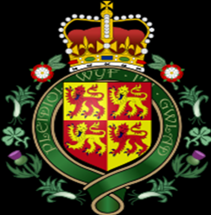
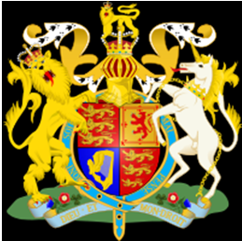

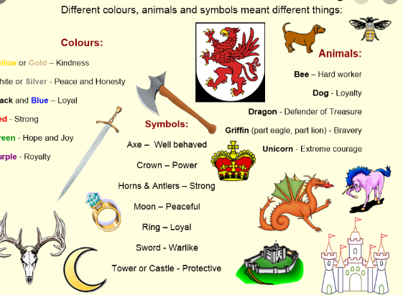

Design your own Coat of Arms. Think about things that are important and personal to you to draw on it.

