Maths | Writing | Art/DT | Science | Other
Count to 100. | Write some sentences to describe this fish.  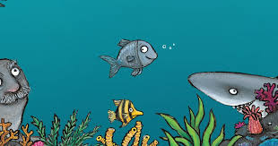 | Make a 3D model of a sea creature. | Read a book or something on the internet about sea creatures. What did you find out? | Read a book to someone in your family.
Go on a number hunt! Can you find any numbers up to 100 in your house? Can you find one more and one less than the numbers you find? | Tiddler the fish in the picture is always late for school! Write a funny reason why he might be late. | Draw a picture to go with your story about why Tiddler is late for school. | What materials can you find in your bedroom? Can you find something hard and something squishy? | Watch a film and write a review explaining what you thought about it.
Make an ice-cream using 2D shapes. | Explore the Great Barrier Reef and write some sentences about what you can see. | Make an ice-cream sundae or another cold treat for a warm day! | Describe the taste and the feeling of your cold treat. | Write a poem about the seaside.
Practice counting in 2s! | Write some sentences about your favourite ice-cream. What flavour is it? What toppings does it have? | Design your favourite ice-cream. | Keep a weather diary over the week. | Think of a word. Can you draw a picture of the word for somebody else to guess?

