Maths | Writing | Art/DT | Science | Other
Count to 100. Use a number square to find different numbers. Can you quiz someone else at home to find numbers? | Write a poem about a sea creature. | Do some seaside or summer themed colouring in. | Look at a picture of a fish. Label its body parts. | Watch a film about a sea creature like Finding Nemo. What animals can you see?
Create a picture of a fish using 2D shapes. | Write a story about this picture:  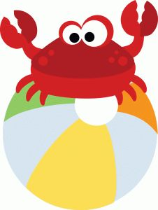 | Collect some pebbles or stones when you are out on a walk. Decorate them with paint or pens. | Research a sea creature and find out what it eats. Is it a carnivore, a herbivore or an omnivore? | Read a book in the garden to someone else in your family.
Practice counting in 5s! | Write a list of picnic foods you would take to the seaside on a sunny day. | Make some picnic foods like sandwiches and enjoy a picnic in the sun. | Use your senses on your picnic. What can you taste, feel, hear, see and smell? | Listen to a song. Can you think of different words for it so it is about the seaside?
Look in your kitchen at home. What 3D shapes can you find? Can you find a cuboid or a cylinder? | Write some things you know about summer. | Draw a picture of what summer looks like. | Make a model boat using things at home. Can you get it to float in water? | Write a poem about summer inside the shape of the sun.

