Year 6 – activities W/B – Term 6 Week 1
 | Maths | Topic/writing  (Victorians) | Creative
Video lessons | Think of the number 34, 567. How was it created? Find 10 different ways.  FOR EXAMPLE: 34,000 + 567 = 34,567 | Do some research on the Victorians and summarise what you found in 10-20 main facts. http://www.primaryhomeworkhelp.co.uk/victorians.html | From what you know about the book so far, design a new book cover for Street Child.  If you wish you can make 2 covers, with different media (paint, pencil, chalk – up to you)
 | 3, 4, 5, 6, 7  Use these 5 digits in FIVE different 3 digit x 2 digit multiplications. Order your answers from smallest to biggest.  Example 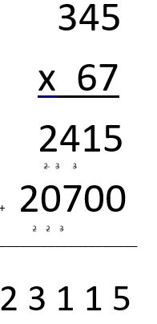 | Following on from the beginning of the text, ‘Street Child’ what do you think happens next?
 | Think of your own 5 digit number. Can you halve it and keep halving it until you get to 1? Is it possible? How long does it take? Make a prediction and then test it. Were you right? | Imagine you were in a Victorian classroom like you saw on the video. Write 10 instructions for the children to follow, which includes important Victorian rules.
Non-video | Practice times tables 2-12 every day | Learn the common exception spellings using speed spell, rainbow words and other methods. | Make write a card to someone from school who you miss, giving them information about how you are and asking them questions?
 | Visit this website and play ‘Countdown’  http://happysoft.org.uk/countdown/numgame.php | Imagine you are a Victorian child. Write your own diary entry. | Design two outfits. One for a rich Victorian, one for a poor Victorian, annotating them to explain you choices.
 | Make a timeline placing the Victorian era in the correct position compared to other historical dynasties. | Here is a street. Think of an adventure that could happen on this street. Plan the story and write it. Maybe make it about Victorians. | Find a recipe you’ve never cooked before where you can get the ingredients and cook it.  Afterwards review the recipe and give it a rating, explaining your rating with reasoning.

