Mundella Home Learning Grid 3 Year 2: 15.6.20
When you have completed a challenge, post it to our school website/FB page:
https://en-gb.facebook.com/pages/category/Elementary-School/Mundella-Primary-School-854575834559906/
Attached Superhero Booklet resource with lots of superhero challenges, writing and arts!

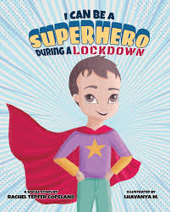 |  | MRS GAMMONS WOULD LIKE TO KNOW WHAT YOUR NEW SUPERPOWERS ARE DURING LOCKDOWN  Post a photo of you showing off your new superpower you have learnt during lock down to : |  | Superheroes Booklet:  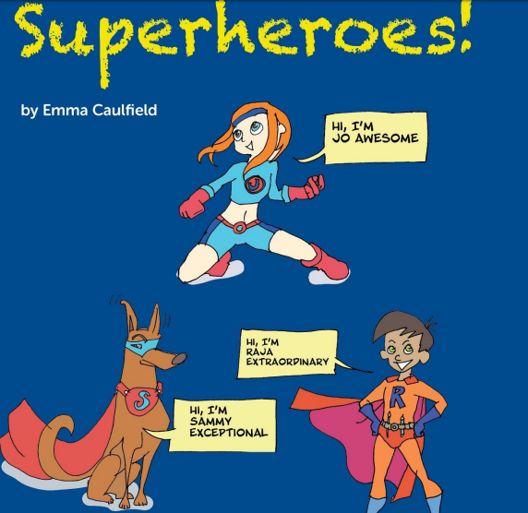
Spelling  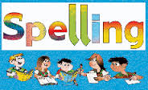  Look, cover, write check on spellings on game-  https://www.topmarks.co.uk/english-games/5-7-years/words-and-spelling |  | Numeracy  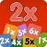  Learn your times-tables FOR X2,X5,X10.  https://www.topmarks.co.uk/maths-games/5-7-years/times-tables |  | Reading  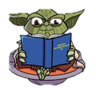  Read at least 5 times each week, OR listen to a story  https://www.storynory.com/
Activity 1  Write the numbers in words:  1) 19  2) 29  3) 43  4) 50  Challenge:  1) 95  2) 82  3 )71 | Activity 2  Solve the following sums:  1) 30 + 20 =  2) 45 + 15 =  3) 30 +20 =  4) 70 + 20 =  5) 90 + 15 =  Challenge:  1) 100 + 20 =  2) 100 + 50 =  3) 125 + 125 = |  | Activity 3  Write number bonds up to 20  For example:  1+19 = 20  2+ 18 = 20  Challenge:  Write number bonds up to 100 |  | Activity 4  Solve the following sums:  1) 10 – 7 =  2) 20 – 10 =  3) 28 – 14 =  4) 32 – 22 =  5) 46 – 32 =  Challenge:  1) 100 – 20 =  2) 100 – 50 =  3) 150 – 50 =
Activity 5  Write a list of adjectives (describing words) to describe where you live.  Challenge:  Write 5 sentences using the word ‘and.’, ‘but’, ‘or’ | Activity 6  Write a paragraph about your family.  Who is in your family?  Do you have any brothers or sisters?  Do you have any pets?  Challenge:  In 2 of your sentences include the word ‘because.’ |  | Activity 7  Write about a dream you’ve recently had.  What happened?  Who was in it?  What did you see?  Challenge:  Use words ‘but, when, so and ‘because.’ |  | Activity 8  Think of the story ‘Goldilocks and the three bears.’  Create a storyboard about the story.  Challenge:  Include speech within your storyboard.
Activity 9  Who is Neil Armstrong?  Carry out some independent research and write up your facts.  POST IT | Activity 10  What can you make out of paper?  For example, a swan or an aeroplane.  POST IT  Ask an adult to help you. |  | Activity 11  Can you name 10 different countries? POST IT  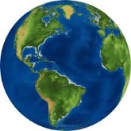 |  | Activity 12  Who is Florence Nightingale?  What is she famous for?  Find an image of her and draw it.  POST IT

