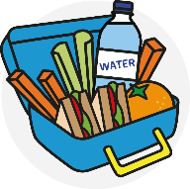
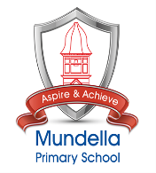
Mundella Primary School
Five Star Lunch Box
CARBOHYDRATE | DAIRY | FRUIT / VEGETABLES | SNACK / TREAT | DRINK
Pasta  Bread  Potato  Rice  (flavoured or filled to taste of child, consider removal of crusts or skins) | Plain Milk  Yoghurt  Cheese  (Preferably not toy foods like strings, strips etc.) | Prepared pots  Whole fruits  Veg Sticks  (Preferably not toy foods like winders etc.) | Crisps  Plain Popcorn  Cereal Bar  Biscuit  (Please avoid high sugar and high salt snacks) | Water  (Plain old corporation Pop. No flavours, no squash, just water.)
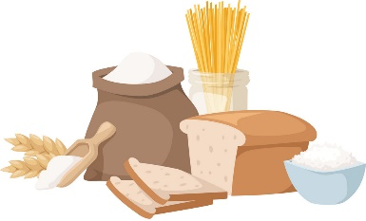 | 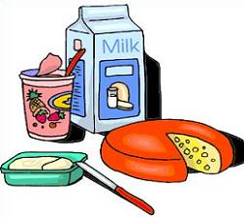 | 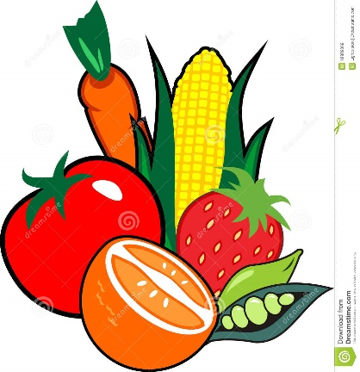 | 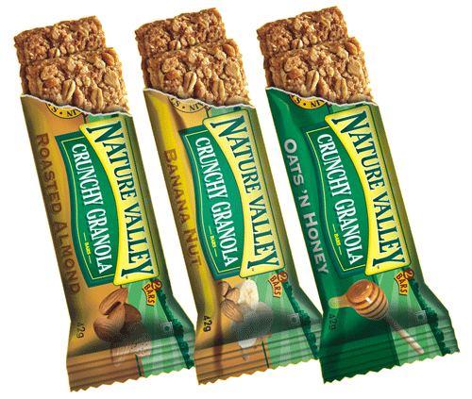
A healthy lunch should have each of these items within it. Slow burning carbohydrates for long lasting energy, dairy for bones and good fats, fruit and veg for vitamins and minerals, healthy treats for happy lunches and plain water for ideal hydration.

