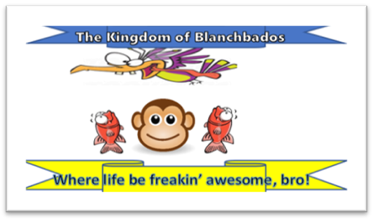
Following the outrageous attack on the Royal Kingdom of Blanchbados by the forbidden and – quite frankly – rude country of Easy Cheesy (how rude!) a decision has been taken to kick their freaking bum bums! Bosh! Both Easy Cheesy and their sister country Lemon Squeezy are rogue states, within the minds of the Blanchados Government!
We have taken a skeleton map of their stinky, cheesy ridden waste land of a country and decided on the areas we wish to target with fruit bombs (because, you know, healthy schools).
We’re…not actually sure how much of this country this strategy will impact on…but we’ll come back to that later…
Your royal and magnificent leader
The Magnificent King Blanche
All hail his beautiful face

