Name - |  |  |  |  |  |  | Date - February 2021
Homework Bingo |  |  |  |  |  |  |  | Year 4 – Term 4  The Legend of King Arthur
Reading  X 5 |  |  | Create your own legend in the style of King Arthur. |  |  | Spelling  X2 |  |  | Log on to times tables rock stars and learn those times tables! |  |  |  | Write a job advert for a knight. Include expanded noun phrases
Spelling  X2 |  |  | Find out about the Saxon gods and create a piece of artwork about them. |  |  | Log on to times tables rock stars and learn those times tables! |  |  | Draw or paint yourself as a member of King Arthur’s court and then label the clothing that you are wearing |  |  |  | Reading  X 5
Write a poem about the King Arthur finding Excalibur. |  |  | Reading  X5 |  |  | Make a model of an Anglo-Saxon village. |  |  | Spelling  X2 |  |  |  | Log on to times tables rock stars and learn those times tables!
Log on to times tables rock stars and learn those times tables! |  |  | Spelling  X2 |  |  | Reading  X5 |  |  | Write a diary entry of a day in the life of an King Arthur. |  |  |  | Turn your poem into a song, can you use things around your house as instruments?
Turn one of King Arthur’s tales into a comic book. |  |  | Log on to times tables rock stars and learn those times tables! |  |  | Handwriting practice:  King Arthur  knight  round table  legend |  |  | Reading  X5 |  |  |  | Spelling  X2
Complete at least two homework tasks per week and earn 3HP per task
You might have to bring evidence in to school or just have your parents sign your reading book to show that you have completed each task.
Earn extra House Points by colouring squares as you complete homework tasks
All four corners = 5hp  A whole line or column of tasks = 5hp  (diagonal, top to bottom, side to side)  Middle for Diddle = 10hp  (complete all 9 tasks on the middle squares) |  |  |  |  |  |  | 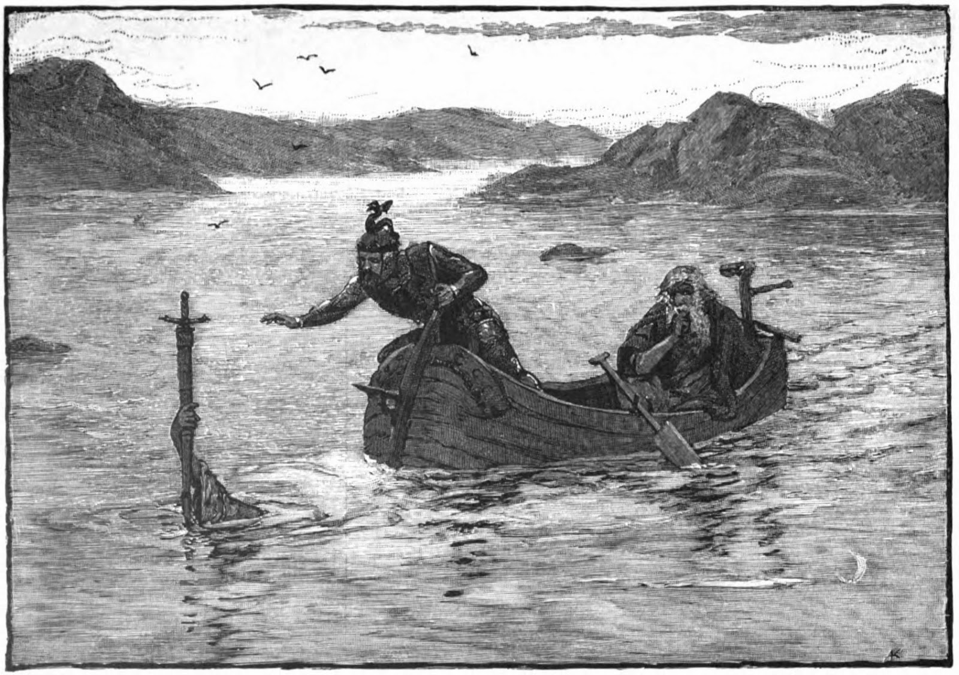  Buffalo Kids = 10hp  (complete all 16 tasks around the outside squares)  Full house = 15hp
C1 | C2 | C3 |  | C4 | C5 |  | D1 | D2 |  | All 4 | Mid | Buff.
R1 | R2 | R3 |  | R4 | R5 |  | Full House

