Name - |  |  |  |  |  |  | Date - June 2021
Homework Bingo |  |  |  |  |  |  |  | Year 4 – Term 6  Off With Their Head!
Reading  X 5 |  |  | Write a diary entry as Henry VIII. |  |  | Spelling  X2 |  |  | Log on to times tables rock stars and learn those times tables! |  |  |  | Research Tudor board games and create your own.
Spelling  X2 |  |  | Research Tudor food and make your own. |  |  | Log on to times tables rock stars and learn those times tables! |  |  | Design a Tudor house. |  |  |  | Reading  X 5
Write a fact file about Henry VIII. |  |  | Reading  X5 |  |  | 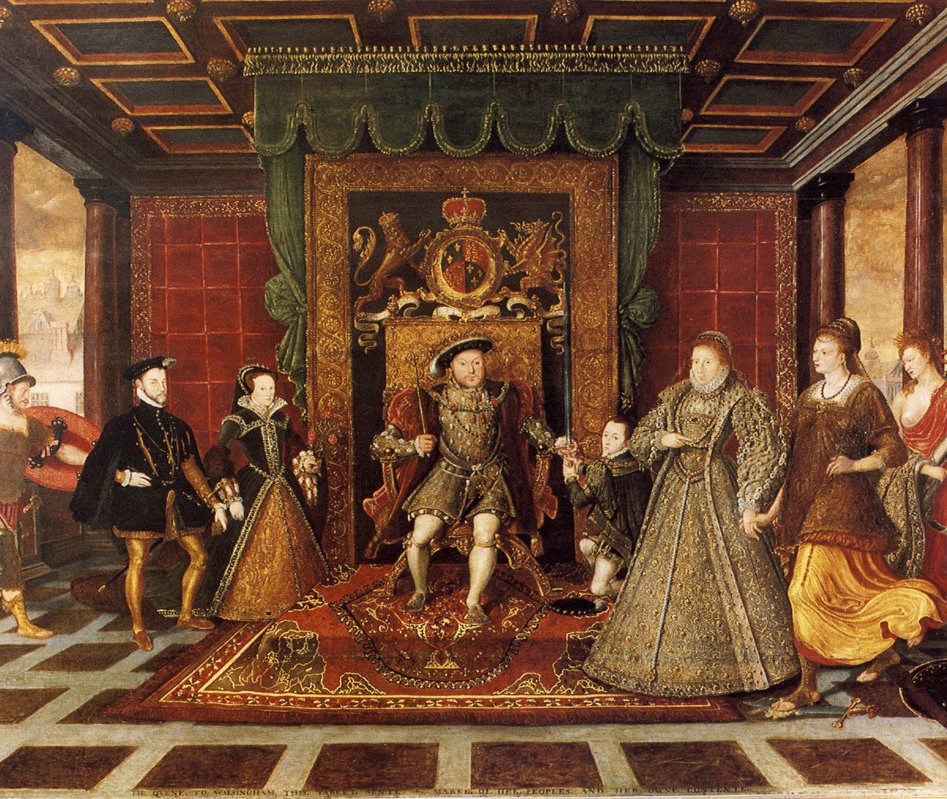  Research Tudor food and create a banquet menu fit for a King! |  |  | Spelling  X2 |  |  |  | Log on to times tables rock stars and learn those times tables!
Log on to times tables rock stars and learn those times tables! |  |  | Spelling  X2 |  |  | Reading  X5 |  |  | Write a message using Tudor calligraphy. |  |  |  | Create a model of Tudor ship.
Design a royal Tudor costume for a King or Queen. |  |  | Log on to times tables rock stars and learn those times tables! |  |  | Handwriting practice:  Henry VIII  Wherry Boat  Tudors |  |  | Reading  X5 |  |  |  | Spelling  X2
Complete at least two homework tasks per week and earn 3HP per task
You might have to bring evidence in to school or just have your parents sign your reading book to show that you have completed each task.
Earn extra House Points by colouring squares as you complete homework tasks
All four corners = 5hp  A whole line or column of tasks = 5hp  (diagonal, top to bottom, side to side)  Middle for Diddle = 10hp  (complete all 9 tasks on the middle squares) |  |  |  |  |  |  | Buffalo Kids = 10hp  (complete all 16 tasks around the outside squares)  Full house = 15hp
C1 | C2 | C3 |  | C4 | C5 |  | D1 | D2 |  | All 4 | Mid | Buff.
R1 | R2 | R3 |  | R4 | R5 |  | Full House

