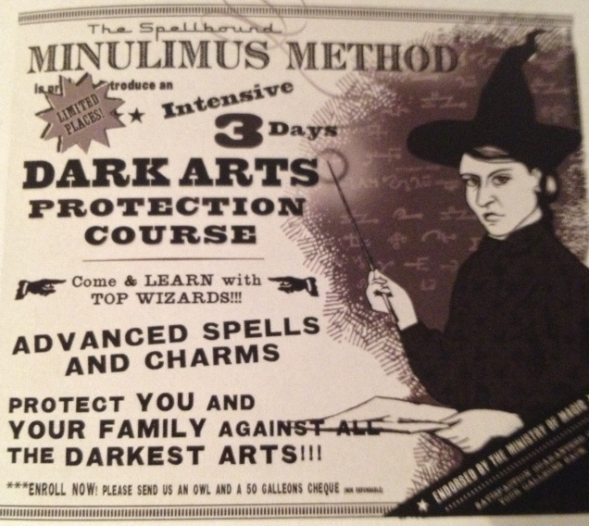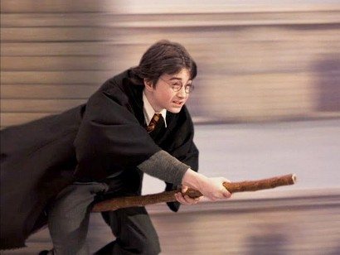

Harry will make his Quidditch debut against Slytherin next week. All eyes will be on Potter to see whether he really does live up to his famous name. Meanwhile, there are rumours that Draco Malfoy and his family have requested to let Draco try out for the Slytherin Quidditch team yet these reports are unconfirmed at this stage. Will potter please his people? Well see you at the match next week to find out!

**Harry Potter: Gryffindor’s New Seeker!**

Following his first flying lesson, Harry Potter, of Gryffindor house, has been appointed as Gryffindor’s new seeker. he will be the youngest seeker in Hogwarts history.

According to an eyewitness, Parvati Patil, Harry had been spotted by professor Mcgonagall completing a fifty foot dive trying to prevent Neville Longbottom’s remembrall from cracking. “I’ve never seen anything like it before” said Patil “coming from a wizarding family myself, I’m used to seeing people on brooms but Harry was a real natural!”

Harrys best friend and sidekick, Ron Weasley said that Draco Malfoy had provoked Harry into getting on his broom “Harry knew he shouldn’t have gone on his broom as Madam Hooch told us not too but Malfoy was teasing Harry and threatened to break Neville’s remembrall! Harry was just standing up for his friends. Harry’s like that, he’s a very loyal person”.

Our journalists have discovered that harry is in fact the youngest seeker in Gryffindor’s history and this is the first time a first year student has ever been allowed to represent their house in Quidditch. according to our archives, Harrys father, James potter, was also an excellent Quidditch player and was in fact a seeker himself!

**FINDERS SNEEKERS!**

THE WIZARD WORLD'S BEGUILING BROADSHEET OF CHOICE

**FRIDAY 24TH JUNE**