[](https://www.google.co.uk/imgres?imgurl=https://66.media.tumblr.com/2e724263042763c8a572f6a9bc16e40c/tumblr_inline_p07sdaHu8S1uniz1z_1280.png&imgrefurl=https://introvertchill.tumblr.com/post/168034399424/hogwarts-houses-a-really-fricking-long-post-by&docid=VSq3eaUWbDIqdM&tbnid=ang61nyLNjwbGM:&vet=10ahUKEwjn2oyyhebgAhUvDmMBHbPkAn4QMwirASgyMDI..i&w=838&h=879&bih=724&biw=1518&q=hogwarts%20houses&ved=0ahUKEwjn2oyyhebgAhUvDmMBHbPkAn4QMwirASgyMDI&iact=mrc&uact=8)[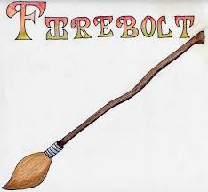](https://www.google.co.uk/imgres?imgurl=http://getdrawings.com/image/broomstick-drawing-55.jpg&imgrefurl=http://getdrawings.com/broomstick-drawing&docid=1HyPSPCoRBzugM&tbnid=EOnDn2ZCdIXAsM:&vet=12ahUKEwjEgq29gebgAhViRxUIHQwIDsI4ZBAzKBswG3oECAEQHA..i&w=800&h=739&bih=724&biw=1518&q=harry%20potter%20broomsticks&ved=2ahUKEwjEgq29gebgAhViRxUIHQwIDsI4ZBAzKBswG3oECAEQHA&iact=mrc&uact=8)[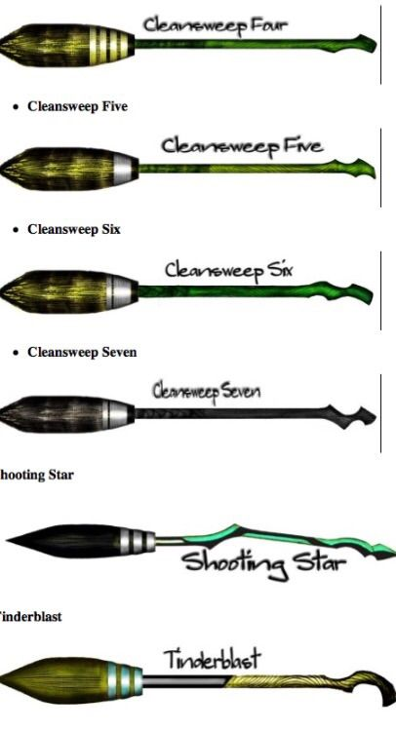](https://www.google.co.uk/url?sa=i&rct=j&q=&esrc=s&source=images&cd=&cad=rja&uact=8&ved=2ahUKEwi9m6eFgubgAhWKx4UKHTnmCT8QjRx6BAgBEAU&url=http://rock-cafe.info/posts/harry-potter-broomstick-drawing-6861727279.html&psig=AOvVaw181QXIqJo5GCHKQXBthvE_&ust=1551703768257911)[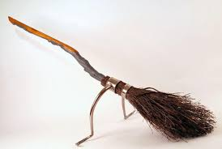](https://www.google.co.uk/imgres?imgurl=https://vignette.wikia.nocookie.net/harrypotter/images/7/74/Firebolt.jpg/revision/latest?cb%3D20141122220040&imgrefurl=https://harrypotter.fandom.com/wiki/Harry_Potter's_Firebolt&docid=ovaTa1B-ZXgFmM&tbnid=M___Jtx6KKo5CM:&vet=12ahUKEwiz6oHQgObgAhULQRUIHVdnCN04ZBAzKEQwRHoECAEQRg..i&w=800&h=536&bih=724&biw=1518&q=harry%20potter%20character%20broomsticks&ved=2ahUKEwiz6oHQgObgAhULQRUIHVdnCN04ZBAzKEQwRHoECAEQRg&iact=mrc&uact=8)[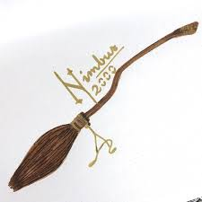](https://www.google.co.uk/imgres?imgurl=https://i.pinimg.com/originals/88/1c/5e/881c5e8c13d29f0ecf73e3d104ab8f47.jpg&imgrefurl=https://www.pinterest.com/pin/424534702366708120/&docid=0OWDNAL-1aiFhM&tbnid=IxFWHtADfP7Y8M:&vet=10ahUKEwixuKaQgebgAhXu1-AKHfKwB4cQMwiRASgiMCI..i&w=640&h=640&bih=724&biw=1518&q=harry%20potter%20broomsticks&ved=0ahUKEwixuKaQgebgAhXu1-AKHfKwB4cQMwiRASgiMCI&iact=mrc&uact=8)[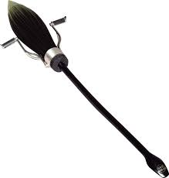](https://www.google.co.uk/imgres?imgurl=https://ya-webdesign.com/images/harry-potter-broom-png-1.png&imgrefurl=https://ya-webdesign.com/explore/harry-potter-broom-png/&docid=whNZYFKGDnnGjM&tbnid=uqj8zq1yN4zdmM:&vet=10ahUKEwixuKaQgebgAhXu1-AKHfKwB4cQMwixAShCMEI..i&w=733&h=768&bih=724&biw=1518&q=harry%20potter%20broomsticks&ved=0ahUKEwixuKaQgebgAhXu1-AKHfKwB4cQMwixAShCMEI&iact=mrc&uact=8)[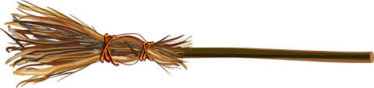](https://www.google.co.uk/imgres?imgurl=https://www.pottedpotter.com/wp-content/images/broomstick.png&imgrefurl=https://www.pottedpotter.com/&docid=thEQ0hwC721UrM&tbnid=HJeXo7Ekc5lIiM:&vet=12ahUKEwjEgq29gebgAhViRxUIHQwIDsI4ZBAzKC4wLnoECAEQLw..i&w=700&h=166&bih=724&biw=1518&q=harry%20potter%20broomsticks&ved=2ahUKEwjEgq29gebgAhViRxUIHQwIDsI4ZBAzKC4wLnoECAEQLw&iact=mrc&uact=8)[](https://www.google.co.uk/imgres?imgurl=http://yourcars.co/wp-content/uploads/2018/05/harry-potter-brooms-harry-potter-broomstick-ride-orlando-harry-potter-broomstick-firebolt.jpg&imgrefurl=http://yourcars.co/harry-potter-brooms/harry-potter-brooms-harry-potter-broomstick-name-generator-harry-potter-firebolt-broom-amazon/&docid=LgN0DVzb9azyeM&tbnid=OFSIm8XlwMi04M:&vet=12ahUKEwjEgq29gebgAhViRxUIHQwIDsI4ZBAzKC0wLXoECAEQLg..i&w=500&h=339&bih=724&biw=1518&q=harry%20potter%20broomsticks&ved=2ahUKEwjEgq29gebgAhViRxUIHQwIDsI4ZBAzKC0wLXoECAEQLg&iact=mrc&uact=8)[](https://www.google.co.uk/url?sa=i&rct=j&q=&esrc=s&source=images&cd=&cad=rja&uact=8&ved=2ahUKEwi9m6eFgubgAhWKx4UKHTnmCT8QjRx6BAgBEAU&url=http://rock-cafe.info/posts/harry-potter-broomstick-drawing-6861727279.html&psig=AOvVaw181QXIqJo5GCHKQXBthvE_&ust=1551703768257911)

**FIREBALL GT100**

**0.3 seconds**

**SHOOTING STAR HYBRID H**

**0.51 seconds**

**DRAGONRAGE 4**

**0.5 seconds**

**DAIGON 1996 SPECIAL**

**0.40 SECONDS**

**CLEANSWEEP 6**

**0.8 seconds**

**SPEED WIZARD GT200**

**0.4 seconds**

**KING-SWOOPER 4**

**0.7 seconds**

**The Hogwarts Broomstick Speed Challenge!**

**Harry challenged his friends to see which of their broomsticks was the quickest from 0 – 60 mph**

**These are the results.**

**Which is the quickest?**

**Which is the slowest?**

**Can you order them?**

**NIMBUS 2000**

**0.2 seconds**