Year 6 Learning Grid (4th – 15th May)
Hello lovely Year 6s. Here is a wide range of lovely activities for you to complete. Enjoy!
Please feel free to keep the school updated on how you are getting on with these tasks.
Mr Blanche
Writing/Reading | Maths | Creative/skills | Physical
Spellings  Look at the common Exception words list.  Practice 5 every day.  Use:  - Speed Spell  - Rainbow Words  - Practice handwriting | Times tables  Visit https://www.timestables.co.uk/speed-test/  Complete different times table tests. | Take a photo of something interesting.  Then try and recreate your picture using drawing/painting/collage. | Complete some Joe Wicks workouts.  These are available each morning on youtube and take approx. 30 minutes.
Use your spellings.  Create your own word search and your own crossword.  Give clues for your cross word for others to solve. | Watch one of Mr De Maio’s timestable songs.  For example https://www.youtube.com/watch?v=9os1VUUp5io  Then choose a table you are less familiar one, learn it in a bit more detail and create your own pop song version of it. | Create a rainbow monster!  Draw a creature which includes every colour of the rainbow. Each colour has to be related a different important feature of the monster so ensure you explain what each colour/feature does. | Watch an athlete on youtube. Learn some of their famous moves or strategies and copy them.
Write a story called ‘The Adventure’. Go to Pobble365, select a random picture and include what you see somewhere in the story. | Take a ONE DIGIT number, double it, keep doubling it.  How long does it take to get to 100?  1000? 10,000? 100,000? 1,000,000?  Make a prediction before you start, maybe try each number from 2-9. | Find items lying around your house. Turn them into props/characters in a show (for example a flower pot could be some sort of house).  Write a script for the show and create a poster. | Complete an exercise routine.  It must involve sit-ups, push-ups and star jumps.  Start with 5 of each.  Each day add 1 more.
Write a letter to someone telling them what you have been upto during Lockdown. | If 9 x 12 = 108. What other facts can you work out?  Find between 10 and 20 facts based on this. | Create a board game based on lockdown. Think about what might earn points/move you forwards and what might lose points/move you backwards. | Practice throwing and catching. How many times can you catch an object in a row without dropping it?
Create a Guide to the Mundella values. Each section must have information about what the value is, how its shown, examples of who shows it and how in addition to how you show it. | Look up a recipe. Work out the ingredients.  Look up the ingredients on a supermarket website and see how much it costs.  Repeat on a different website and compare the price.  You can compare more than one if you wish and you can also design your own price comparison website! | Design a home that people would wish to stay in.  Consider all the things you feel are important in terms of what makes people happy and keeps them going. | Get a balloon. Blow it up.  See how long you can keep it up in the air but kicking/bouncing it off your hand.
Think of people who have been helping in the community. Write a thank you letter to them to thank them for their efforts. | 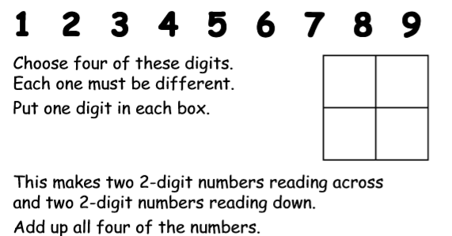  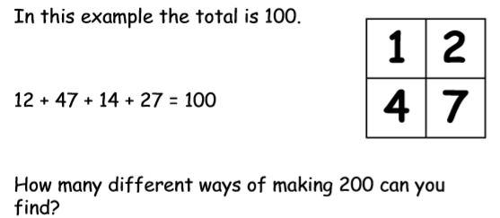 | Design a machine for the tooth fairy which follows social distancing rules.  How are they to get a tooth from under a pillow from 2 metres?  Design, draw picture, label and annotate. | Build a den in your room. How can you build it so it stays up?  (Remember to clean up afterwards)
Make a persuasive argument. Decide who to give it to. Base the argument on whether lockdown should be removed or extended. Consider elements like schools and parks. | 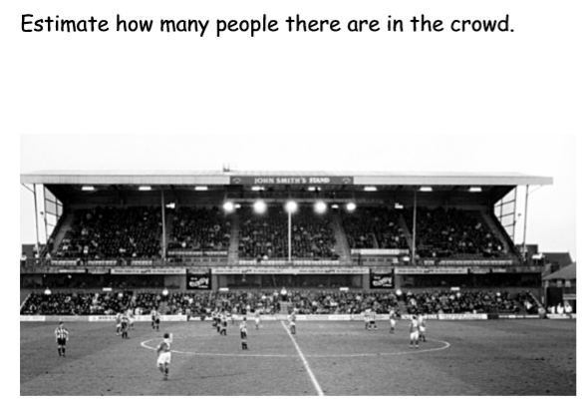  (This photo was taken a long time before social distancing) | Think of your favourite animal.  Imagine there was a hotel for that animal. What would it need to include?  Design it. | Ask your parents for a household chore you don’t normally do. Do a different one each day.  Decide which was your favourite and make it your new job in the house.
Reverse a fairytale.  For example The Three Little Pigs.  Imagine they are the villains and the wolf is the hero. What would happen?  Write it. | 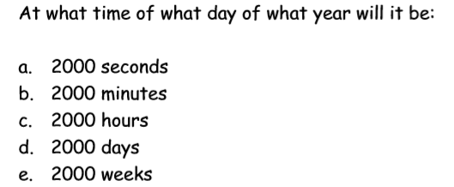  After the start of 2020? | What do you remember about Mundella?  Draw a map of the school. Label as much as you can.  As an extra challenge set the map out on a co-ordinated grid. | Alphabetical scavenger hunt  Search round your house for 26 different items, each one beginning with a different letter of the alphabet.  Try and complete it within a set time.
Read a poem from the selection.  As you reading it draw what images come into your mind.  Annotate what you draw. | In May there are 31 days  How many weeks is this?  How many hours are there?  How many minutes?  How many seconds?  Can you make up your own similar enquiry? | Find 5 items of clothing. Each of a different colour.  Create an outfit out of them  Draw it, model it, describe it to make it sound like the best outfit ever! Make an advert to advertise the outfit. | Set up a throwing activity. Create a target to throw at. If you reach it three times, move the target further away.  Alternatively make 3 targets, each one with several points attached. Add up your score after a number of throws. Can you beat your score?
Watch the video of Jemima reading a book. What was the book about?!  Retell the story | 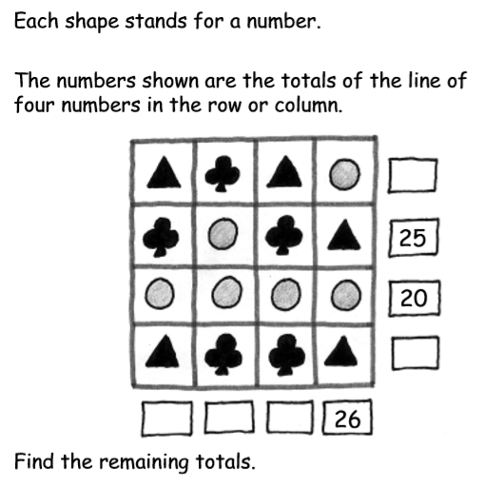 | Mr Blanche desperately needs a haircut. Design a new haircut for him and persuade him why this one would be perfect for him. | Go to youtube, type in cosmic yoga.  Complete one of the cosmic yoga sessions (various themes available such as Harry Potter/Pokemon etc)

