Home Learning |  |  | Grid 2  Year 4
Put some water ata different heights into drinking glasses.What do you notice? Make up a tune and …  POST IT | 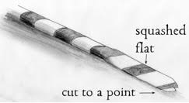Make drinking starw oboes. (see attached instructions). Record what you learn or a tune that you make.  POST IT | https://www.bbc.co.uk/bitesize/topics/zgffr82/articles/zstr2nb  Watch the clips about sound. Complete each quiz. Make a poster about what you have learnt.  POST IT | Carry out a sounds survey around your home. How many different sounds can you find? Can you group the sounds? What criteria would you use? Eg, loud sounds/quiet sounds.  POST IT |  | Look through ‘Sounds Like Science’ and choose some activities to do in your home. Take a picture of what you make.  POST IT
Go for a walk and listen out for environmental sounds. Make a map of your walk and include a colour coded key to show where you heard a scale of different sounds. (loud to soft).  POST IT | Read the Sound Collector poem. Identify and list the rhyming words. Add more to each. Can you write your own sound poem using the same rhyming patter? Illustrate and …  POST IT | Log in to https://connect.collins.co.uk/school/MUNDELLA1/Student/  Date of birth  First letter of surname  Year group  Go to The Treasure House and complete a task every day from each section. | Log in to https://connect.collins.co.uk/school/MUNDELLA1/Student/  Year group  Busy Ant Maths.  Use the times table simulator and practice your times tables every day.  Choose another section of maths to revise every day. |  | Log in to https://connect.collins.co.uk/school/MUNDELLA1/Student/  Year group  Go to the Big Cat book shelf and choose a book to listen to or read yourself. Make a poster about the book, write a book review or draw a picture of your favourite character/part.
https://museum.maidstone.gov.uk/learn/learning-with-spike-at-home/  Go to the Takeover Tuesday and revise Ancient Egypt.  Explore the other activities on the museum website. | Make your own Ancient Egyptian cuff/bracelet.  Cut up a toilet roll centre and decorate.  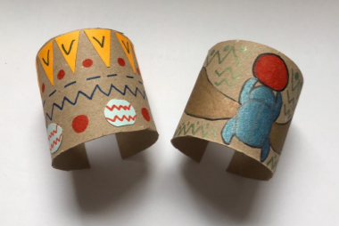  POST IT | Make an obstacle course using cushions. https://www.youtube.com/watch?v=v7V_uKNvxvk  Watch the clip for ideas if you are stuck! Ask an adult to film you doing the course and  POST IT | Roll a dice and complete a different exercise for each number thrown for 20 minutes.  Eg,  1=10 star jumps  2= 10 frog hops  3= jog on the spot. Etc.. |  | Complete a daily WAKEUP and SHAKE UP!  https://www.nhs.uk/10-minute-shake-up/shake-ups
Find different 3D shapes around your home. Sort them into groups and POST IT  Don’t forget to tidy everything away afterwards! | Draw or paint the view from each window in your house. How is each view different?  POST IT | Observe and make a diary of the moon every night for the next month. Find out the names of the different moon shapes. What do you notice about the moon?  POST IT | Make a weather diary for a month. Use a weather app or the TV weather report to record the daily temperatures. Are there any patterns in the temperature or the weather?  POST IT |  | Collect different tree leaves when you are out for a walk. Draw them and find out whih tree they came from. What similiraities and differences did you notice? Are all the leaves on a tree the same size? Find out by looking at different trees, Record what you find out.  POST IT
When you have completed a challenge, post it to our school website/FB page: https://en-gb.facebook.com/pages/category/Elementary-School/Mundella-Primary-School-854575834559906/ |  |  |  | Have fun! Stay safe!  Mrs Blunden and Mrs Stockley.
Don’t forget to use the attached resources too.

