Outdoors Scavenger hunt
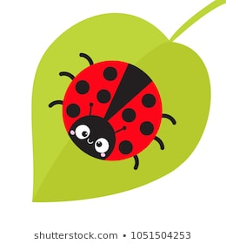
- Find 3 types of leaves
- Find a stick
- Find a snail
- Find something colourful
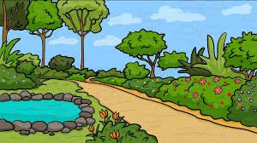
- Find a flying insect
- Find a flower
- Find a tree
- Find an ant
- Find a feather
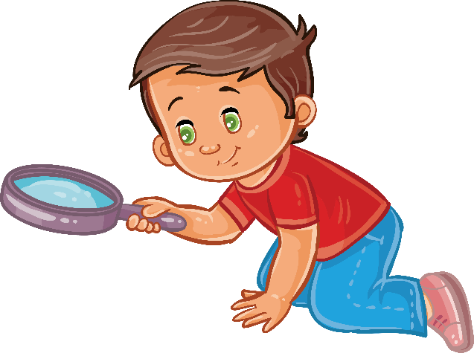
- Find a worm
- Find some soil
- Find a rock
- Find a butterfly

