Science Scavenger hunt
- Find something that floats on water
- Find something living in your garden
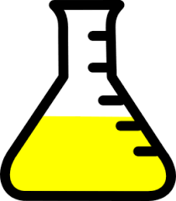
- Find something that makes loud noises
- Find something that melts
- Find something stretchy
- Find something that plants need to help them grow
- Find something that sinks in water
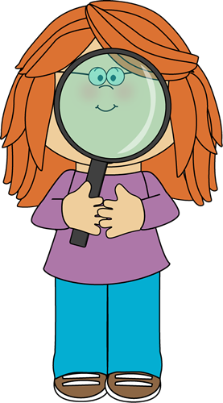
- Find something hard
- Find something that smells nice
- Find something squishy
- Find something magnetic
- Find something that makes a quiet sound
- Find something that tastes nice

