Name - |  |  | Date – 20.4.20
Spring Learning  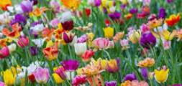 |  |  |  | Grid 1  Year 2
Make a 3D caterpillar from an egg box  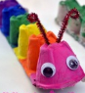  POST IT | Make a bug hotel  in the garden  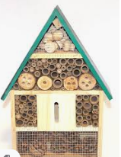  POST IT | Draw and colour in a bug hotel  POST IT |  | .  Classify different bugs into groups that you find  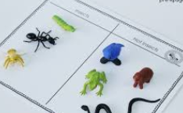 | .  Write a fact file for a bug  POST IT
Write, name and draw 10 bugs | Write a riddle/poem  about a mini beast  POST IT | What the Ladybird Heard by Julia Donaldson:  Design a new front cover |  | .  Paint a symmetrical mini beast eg ladybird, butterfly  POST IT | Find some beads, thread them and turn it into a caterpillar
Write an acrostic poem about your mini beast  POST IT | Perform the song:  What the Ladybird  Heard by Julia Donaldson  ladybird | .  Take photos of insects  POST IT |  | Draw/make a spiders web or a snail  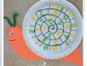  POST IT | Make a lily pond with water in a tray. Use a sponge and make green frogs  POST IT
Go on a bug hunt and count how many bugs you find | Listen to the story of What the  Ladybird Heard by Julia Donaldson  ladybird | Make some cakes in the shape of a bug  POST IT |  | .  Make a mini beast out of natural things FROM YOUR GARDEN if you can  POST IT | Make a model of your favourite bug  POST IT
Make minibest patterns with curves, spirals and wiggly lines | Watch the Very Hungry Caterpillar  by Eric Carle  caterpillar | Write a story about a bug:  Who, where, what happens?  POST IT |  | Draw 3 worms  2cm, 4.5cm and 8cm | Find some stones and turn them into bugs  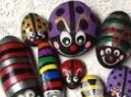  POST IT
When you have completed a challenge, post it to our school website/FB page:
8office@mundella.kent.sch.uk

Have fun! Stay safe!
Mrs Gammons
Attached resources too for spellings, times tables and 60 second reads bugs comprehensions

