Rainbow Scavenger Hunt
- Find something red
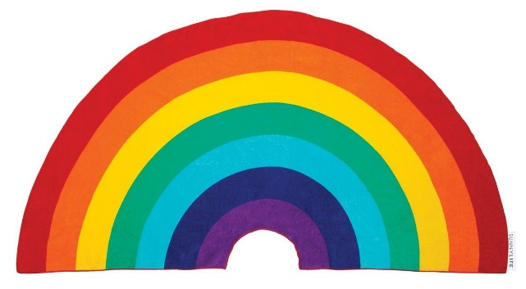
- Find something orange
- Find something yellow
- Find something green
- Find something blue
- Find something purple
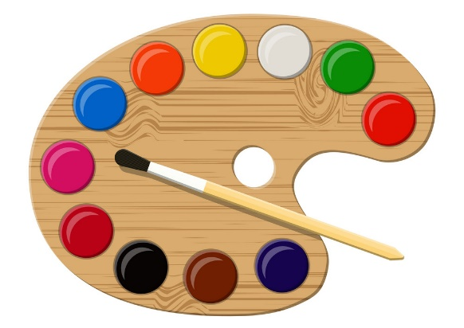
- Find something pink
- Find something black
- Find something white
- Find something multi-coloured
- Find something your favourite colour
- Find something light coloured
- Find something dark coloured

