Name - |  |  | Date – w/c : 4.5.20
Indoor Learning  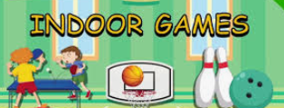 |  |  |  | Grid 2  Year 2
Listen to a talking book:  storynory  It’s FREE! | Create a symmetrical butterfly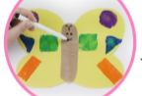 | Write an acrostic poem about the NHS and draw some pictures of a rainbow  POST IT |  | Make a chatterbox  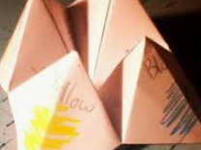 | Look out your window and write down as many birds and flowers that you can see. Write a setting description: POST IT
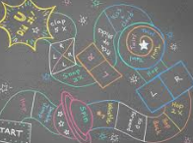  Make a hop scotch of activities in your street- count in 2s, 5s, 10s | Make a table football game with a friend using a paper ball and make goals | Learn how to sew on a button  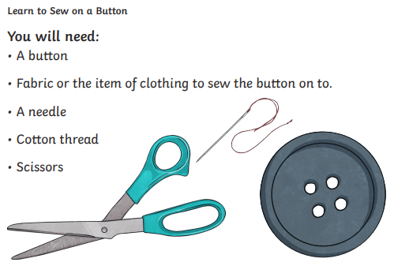 |  | Write out a recipe: make it, bake it, cook it  POST IT | .  Make a cushion from an old tee shirt  POST YOUR DESIGN
Fitness:  count in 10s to 100 and do star jumps, hop on one foot and squats | Make up some songs and jokes- POST IT | Fitness:  Do 10 sit ups, 10 jumping jacks and 10 press ups x 3 times |  | Have an X factor show/party- play musical bumps | Fitness:  When you go for a walk, spot as many numbers as you can outside – door numbers, cars, signs
Build a den, castle or tower with pillows, cushions, blankets and boxes- Post photos | DIY Balance Beam:  A line of tape on the floor and walk along it straight | Play card games- pairs, pontoon, snap  Use your maths |  | Have a games night  POST YOUR PHOTOS | WATCH LIVE WEB CAMS-  zoo
Paper & Pencil Games:  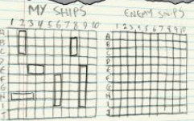  Battleships | Paper & Pencil Games:  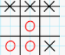  Noughts/  Crosses | Paper & Pencil Games:  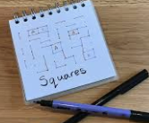  Squares |  | Paper & Pencil Games:  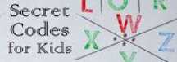  Make up a secret code:  Post it for others to solve | museum  POST YOUR RECOUNT OF YOUR VIRTUAL VISIT TO THE ZOO OR MUSEUM
When you have completed a challenge, post it to our school website/FB page:
8office@mundella.kent.sch.uk

Have fun! Stay safe!
Mrs Gammons
Attached resources too for spellings, times tables and 60 second reads bugs comprehensions

