Mundella Primary School
Handwriting
Intent
At Mundella Primary School, we strive to support children in their development of a neat, legible and fast handwriting style. Through observing, modelling and repeated practice, pupils develop the ability to produce letters automatically. To develop this style children experience coherence and continuity in learning and teaching across the school. They will develop a recognition and appreciation of pattern and line whilst understanding the importance of clear and neat presentation in order to communicate meaning clearly. Children are encouraged to take pride in the presentation of their work and therefore study handwriting with a sense of enjoyment and achievement. We intend for children to be able to write quickly to aid expressing themselves creatively and imaginatively across the curriculum and for a range of purposes.
Implementation:

Handwriting is a complex skill to learn and starts well before a child is ready to pick up a pencil and make marks on paper.
To develop good handwriting children need to:
- Have good whole body strength and dexterity (Gross & Fine Motor Skills).
- Understand direction, movement and position (Spatial Awareness & Motor Memory).
- Remember and recall how to form the different shapes of the letters (Visual & Motor Memory).
- Sit correctly (Gross Motor Skills).
- Hold a pencil appropriately (Fine Motor Skills).
- Control the pencil (Fine Motor Skills).
- Tilt and move the paper on the desk (Gross Motor Skills & Spatial Awareness).
- Refine letter formation and position (Fine Motor Skills, Visual & Motor Memory, Spatial Awareness & Eye Tracking).
- Join the letters to form words (Fine Motor Skills, Visual & Motor Memory, Spatial Awareness & Eye Tracking).

All these skills and strengths are learnt and developed in stages as a child grows. A weakness in any of the Key Strength areas will affect a child’s handwriting skills.
All handwriting lessons have a similar structure. Lessons begin with warm up activities to prepare the body for writing these include an activity to develop and build hand and wrist strength, upper body strength and improve co-ordination. These warm up activities are aimed at developing gross and fine motor skills to build strength and stability, and visual perception skills to discriminate between different letter shapes.

We have a whole school cumulative approach to handwriting. Children begin their journey learning pre-handwriting patterns as the first step in handwriting. Pre-handwriting patterns help them to learn the shapes and directional pushes and pulls of the writing tools required to form letters. All letters are a combination of these shapes and lines.
To support our approach to handwriting, children use the handwriting formation descriptions from the Twinkl Handwriting Scheme.

EYFS
We recognise that the children at Mundella start EYFS at a variety of stages, some are starting to move from a simple grasping (primitive) grip to one that secures the writing tool between the fingers and the thumb and some are still developing their gross motor skills. At Mundella, children’s first experiences on their handwriting journey involves mark making and simple drawings, whether it is with finger paints, writing in sand or with pencils and crayons. Children then are introduced to pre-handwriting patterns.
Once children have mastered the pre-handwriting patterns, they will have the skill base necessary, and be more confident, to form letters, numbers, symbols and later-on the join strokes required for a joined fluid and speedy handwriting style.
During the first two terms at Mundella, we aim to develop children’s body (gross motor skills), hand strength and dexterity (fine motor skills) through the use of a range of pencils, crayons and paint brush thicknesses. These are developed through the use of vertical drawing and painting surfaces as it is recognised how important this is to develop the wrist strength and flexibility that children will need later on to hold a pencil correctly for handwriting.
We provide opportunities to use large plain rather than lined paper initially as many children find it less restrictive. Children, due to the stage of their physical development, tend to use large movements to draw initially (from the shoulder rather than the wrist) which often creates larger shapes and lines. To support this, we undertake large body movement actions in songs and rhymes and through dance movements with scarves and ribbons.
As the children develop gross and fine motor skills, so does their pencil grip and ability to draw and write at a smaller scale, moving more from the elbow and wrist. Children at Mundella develop and learn many of these directional pushes, pulls and changes in direction on a much larger scale, long before they pick up a pencil, through playing with cars or pretending to cook. These movements become the drawings/scribbles which children form once they start mark-making, initially as big uncontrolled movements then becoming more controlled and smaller as their gross and fine motor skills develop.
Initially learning to form letters is less formal, using a range of media and game type activities e.g. drawing letters with paints or in sand. We model and explain how to make the letter shapes with the correct starting point, directional flow of the tool, or hand, and finishing point, using the picture prompts from Little Wandle phonics scheme adopted by Mundella whilst applying the Twinkl formation phrases.
Letters are created through joining lines and curve shapes in a particular way. They have a designated start point and set directional pushes and pulls of the pencil to reach the designated finish point. This is why we teach letter formation in groups/families rather than in alphabetical order. Certain groups use the same, or similar, shape and directional pushes and pulls of the pencil to form the letter. This is also explicitly taught and shared with children.
Year 1 to Year 6
Children are taught handwriting formally through modelling by the class teacher followed by observed practice of the children. This is to prevent children from forming bad habits which impact negatively on their letter formation, hindering the desired fast paced fluent style.
Through the structured use of the Twinkl Handwriting scheme, teachers are guided by the scheme to teach a logical approach using the letter families with an opportunity to use professional judgement should children need a shorter or longer period of practice.
Whilst Twinkl provide a number of additional worksheets, these are only adopted for scaffolding purposes, generally we ask children to write straight into their handwriting book which contain lines similar to the ones used in topic lessons enabling children to develop and secure continuity of handwriting across the curriculum.

Equal Opportunities
The school is committed to ensuring the active participation and progress of all children in their learning. All children will be given equal opportunities to achieve their best possible standard, whatever their current attainment and irrespective of gender, ethnic, social or cultural background, home language or any other aspect that could affect their participation or the progress of which they are capable.
Inclusion
Differentiation occurs through the support and intervention provided for different children. There is little differentiation in the content taught however the activities provided contain additional scaffolding for children who need it. Children’s difficulties and misconceptions are identified through immediate formative assessment and addressed with rapid intervention – commonly through individual or small group support in Guided Learning sessions or within the lesson.
A range of inclusion strategies, disseminated by the SENDCO, are embedded in practice and teachers are aware of the special educational needs of the children in their class, as well as those who have English as an additional language.

Handwriting Scheme.
Children begin letter formation with ‘journey to cursive’ resources in EYFS and Year 1. In Year 2 and beyond, children progress to ‘journey to continuous cursive’ resources.
In EYFS children learn how to form lower case letters correctly alongside numerals 0-9.
In Year 1, children recap lower case letters and numerals and are introduced to capital letter formation. We continue to follow the Twinkl scheme for teaching capital letter and numeral formation.
In Year 2, children progress to learning cursive letter formation in preparation for joining letters in KS2. They will recap numerals and capital letters. (Step 3)
In Years 3 and 4, children move onto step 4, joining letters.
In years 5 and 6, children move to step 5, increasing fluency, style and speed.

EYFS
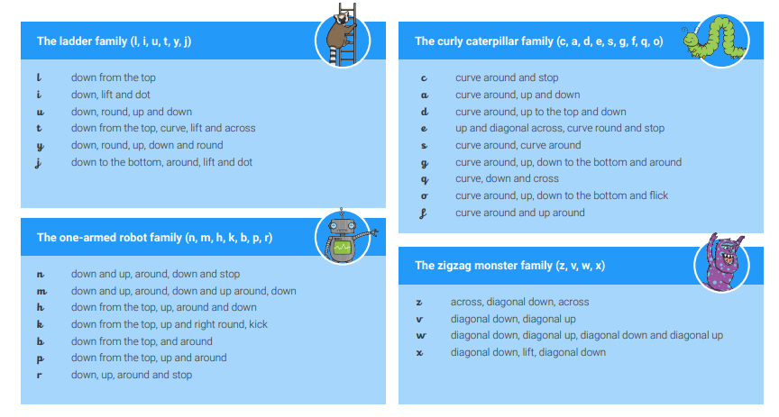
Delivered initially through gross and fine motor skill activities, progressing to letter formation using the Twinkl formation guides. Staff model the letters to children using the Little Wandle pictures but adopt the Twinkl formation chart to describe the letter shapes. This use of the Twinkl formation continues across the school enabling a smooth transition from class to class.

Year 1
During year 1, children revise how to form all letters of the alphabet and numerals using a printed style. All topic lessons reinforce accurate letter formation and staff quickly identify and correct bad habits in a timely manner with additional personalised learning.
Capital letters and number formation are taught as part of topic lessons and guided learning sessions in the handwriting book. This could be at the start of a topic lesson as a writing lesson warm up. Numerals are taught explicitly as part of maths or guided learning lessons. Capital letters are taught using the sequence outlined below. Lessons follow a specified format of a gross and fine motor skill warm up followed by letter formation practice.

Capital Letter Formation
Skill | Letters
Capital letters no lifts | V, W, N, Z  C, O, S, U  L, D, P
Capital letters with 1 lift | M,  B, R  K, Y, X  Q, G
Capital Letters with 2 lifts | E, F, I, T, H  J, A

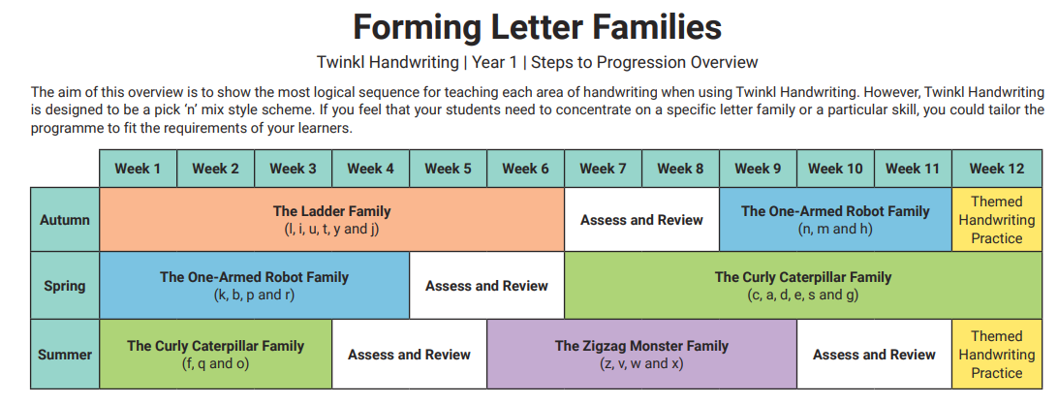

Year 2
In Year 2 the children move to pre-cursive letter writing.
Capital letters and number formation are taught as part of topic lessons and guided learning sessions in the handwriting book. This could be at the start of a topic lesson as a writing lesson warm up. Numerals are taught explicitly as part of maths or guided learning lessons. Lessons follow a specified format of gross and fine motor skill warm ups followed by direct letter formation instruction.

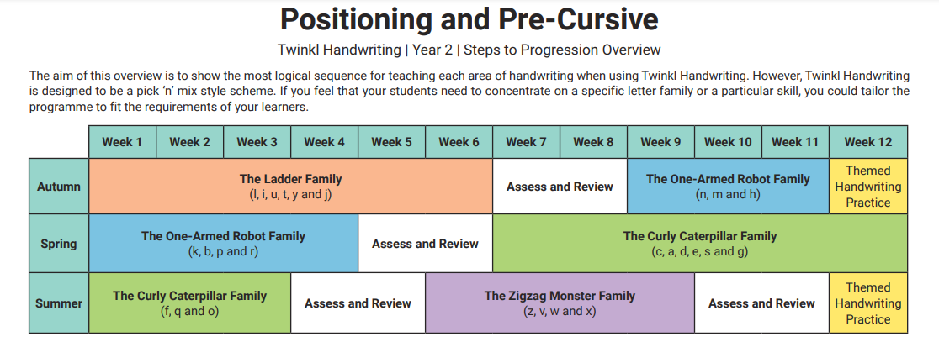

Revise capital with one lift
Revise capitals with no lifts
Recap numerals

Years 3 and 4
In years 3 and 4, children are taught how to join letters. Children are expected to have already mastered the formation of capital letters and numerals. For those children falling behind, targeted interventions are delivered. Lessons follow a specific formula of gross and fine motor skills warm up followed by focussed instruction.
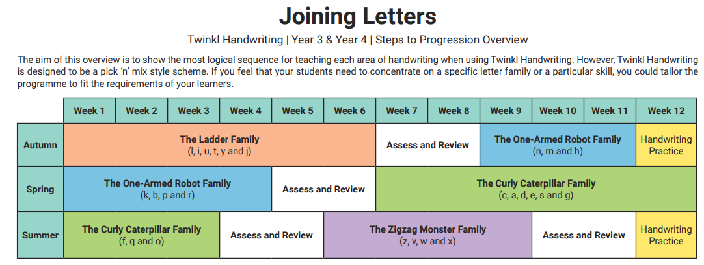
Years 5 and 6
In years 5 and 6, children are taught fluency, speed and style. Children are expected to have already mastered the formation of capital letters and numerals. For those children falling behind, targeted interventions are delivered.
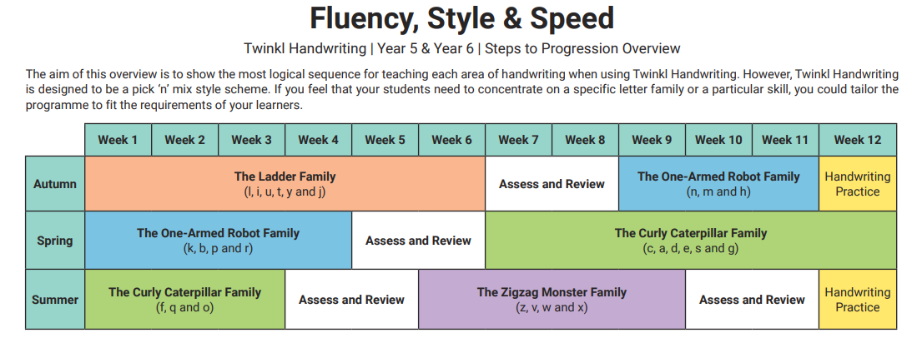

Impact
Children are assessed using the National Curriculum criteria objectives throughout the year on Sonar, the school’s tracking tool. With the structured progressive approach to handwriting, children develop a fast and fluent style to handwriting. Once letter joining is developed, children earn the use of a handwriting pen which they then use in class (this is usually once children are in year 4). Children apply their handwriting skills to produce writing in a variety of genres for different purposes (see the English Writing Curriculum document). Through the application of the Twinkl handwriting scheme, children falling behind are quickly identified and supported with rapid catch-up during interventions.

