Mundella Primary School

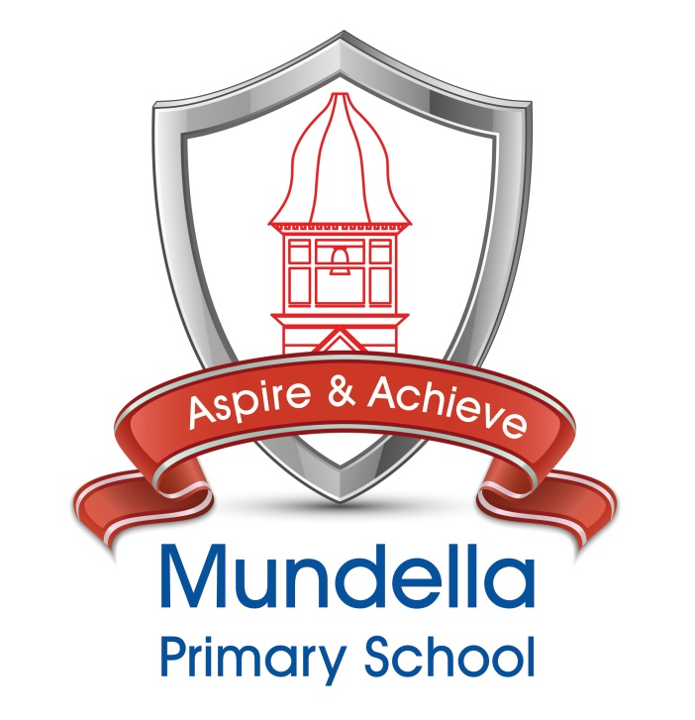

School Welcome Pack 2022

To be retained for your information.

School Uniform

As a school we feel that it is important that the children come to school ready to learn and wearing the correct school uniform helps them to do this. The school wishes to promote a sense of pride and belonging in our children and believes that the wearing of a school uniform is one of the ways in which this can be achieved. The uniform is simple and practical, suited to the demands of a primary school education and economically priced.
Daily Uniform | P.E. Kit
Red polo shirt  Grey trousers or trouser shorts  School sweatshirt or sweatshirt material cardigan with Logo  (no fleeces indoors)  Plain Black Footwear  Grey skirt  Red, grey or navy blue tights in cold weather (not leggings)  Red gingham dress in summer (optional) | - Plain navy blue shorts  - Plain navy blue or grey jogging bottoms in cold weather  - Team colour t-shirt (first t-shirt is provided by school)  - No earrings to be worn.  - Black or white gym shoes  - Whilst in EYFS, it is advisable that children do not wear earrings to school as their curriculum requires a great deal of activity.  Blue Green Red Yellow  Water Earth Fire Air  In addition, when children are older:  - A basic wrist watch (no smart devices)  (example watch)  - Stud earrings only may be worn (due to Health and Safety) If worn, children must be able to remove them for P.E. by themselves.  - If a child is unable to remove them themselves, they will not be allowed to take part in the physical activities of the lesson.
Please note:  - ‘Plain’ describes our expectation for a single colour without patterns, logos or large branding.  - Shoes with wedge soles or high heels are not suitable for school wear.  - NO TRAINERS, suitable black shoes or boots (in the colder weather) should be worn for school.  - No other jewellery to be worn to school including Tag days.  - No make-up including nail varnish to be worn to school including Tag days. | Order your uniform online;  http://www.channeluniforms.co.uk/  https://www.hawkingeuniforms.co.uk/

ALL ITEMS OF CLOTHING MUST BE CLEARLY MARKED WITH YOUR CHILD’S NAME.

Children are allowed to wear their own clothes to school on their birthday, or on the Monday or Friday should the date coincide with the weekend. During EYFS it is advisable that children bring spare undergarments to change into should the need arise. (Please also ensure that these are named). Spare clothing is available in an emergency. Any borrowed items must be washed and returned the following day.
Senior Management Team
Mr Frazer Westmorland  Headteacher | Mrs Lauren Wharmby  Deputy Headteacher &  SENCO | Mrs Lisa Paez  Deputy Headteacher | Mrs Louisa Blunden  Assistant Headteacher  Phase 1 Leader
Staffing

Mrs L Blunden  Assistant Head teacher  Class Teacher  and  Phase 1 Leader | Mrs M Fry  Phase 1 Teaching Assistant  and  Breakfast Club
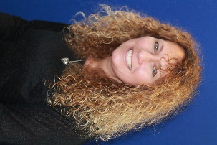 | 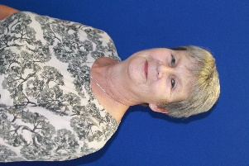
Mrs S Jackson  Phase 1 Teaching Assistant | Mrs Carol Gretton  Senior Family Liaison Officer
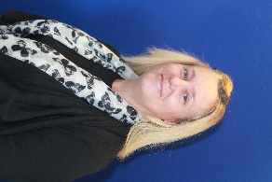 | 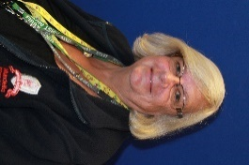

Our School Values

Each term we celebrate our school values by presenting button badges to pupils in each year group. They wear them with pride, around the school, as a visible symbol of living by the values that each colour represents.
Pupils strive towards earning each of the colours at which point they are presented with a gold button badge.

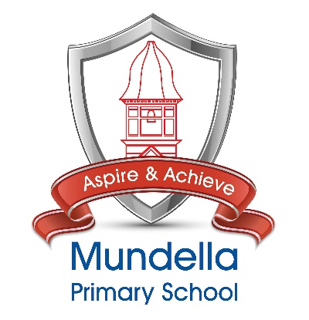 | Mundella Primary School
ASPIRE
We believe that our children can be whatever they wish to be.
We want them to aim high and become members of society that really make a difference.

ACHIEVE
Our drive is to equip children with the skills that they need to meet their academic and personal goals.
 | Our School Values
Caring | Develop the skills and ability to care for themselves, property, peers and the whole community and make a difference.
Creativity | Develop and explore skills, imagination, confidence and new ideas.
Respect | Treat eachother, the environment, our community and possessions as we would wish to be treated in return.
Independence | Develop the initiative, confidence and self-esteem needed to achieve today and in the future.
Collaboration | Think together, work together, achieve together, celebrate together.
Honesty | Be true to yourself and to others even when it is tough.

Mundella Primary School

School Welcome Pack 2022

To be completed and returned to school

Child’s name:________________________________________

Equal Opportunities Form

Full Name of Child:……………………………………………….. Date of Birth:…………………
Every school has to collect information about the ethnicity of its pupils and the special educational needs of its pupils, to ensure admission arrangements are fair.
Please complete the following questions:
- What is your child’s ethnic group? (Please tick)
White  British  Irish  Gypsies  Other White background | Mixed  White and Black Caribbean  White and Black African  White and Asian  Other Mixed background
Asian or Asian British  Indian  Pakistani  Bangladeshi  Other Asian background (please state:____________________________) | Black or Black British  Caribbean  African  Other Black background (please state:____________________________)
Other  Chinese  Other ethnic group not listed (please state:____________________________) | I do not wish my child/my ethnic group to be recorded in any way

- Does your family normally speak at home, in a language other than English? Yes/No
If yes, what language is spoken?__________________________________________

- Do you believe your child has Special Educational Needs or a Disability? Yes/No
If yes, please give details:

- Have you been advised by anyone (early years teacher/pre-school advisor/health professional etc.) that your child needs additional support? Yes/No
If yes, please give details:

Signature of Parent/Carer_________________________________________

Name of Parent/Carer____________________________________________

Date_______________________________

NEW ADMISSIONS INFORMATION
HEALTH  1. Does your child have any health condition or disability? |  | Yes |  | No
If yes,
1a. Has it lasted or is it expected to last 12 months? |  | Yes |  | No
1b. Does this have a substantial effect on your child’s ability to carry out day to day activities? |  | Yes |  | No
2. Does your child take regular medication? |  | Yes |  | No
3. Does your child regularly need to use an inhaler? |  | Yes |  | No
4. Does your child have any allergies? If yes please write full details overleaf. |  | Yes |  | No
EDUCATION  1. Does your child need to wear glasses? |  | Yes |  | No
1a. Do they need to be worn all day or at specific times? |  | Yes |  | No
2. Does your child have any speech or language difficulties? |  | Yes |  | No
3. Does your child have any hearing difficulties? |  | Yes |  | No
4. Does your child have any physical difficulties? |  | Yes |  | No
4a. Does your child have difficulty moving about the school and going on school visits? |  | Yes |  | No
5. Does your child have difficulty washing, going to the toilet, controlling the need to go to the toilet, dressing etc.? |  | Yes |  | No
6. How does your child get to school? (circle one) |  | Walk | Car / Share | Bus | Taxi
Please give details overleaf if you require support in any of the following ways or if you think there is anything we should be aware of:
Support with information sent from school in alternative formats e.g. Braille, large print, specific access requirements to the school buildings or to enable you to take part in consultation meetings e.g. interpreters for British sign Language, loop system, explaining things over the phone.
Date……………………………… Signed (Parent/Carer)……………………………………….

Contact Email Address……………………………………………………………………………….

Please use this space to provide any details from any of the sections overleaf:

UNIVERSAL SCHOOL MEALS ELIGIBILITY FORM

All pupils up to age 7 are entitled to a ‘free’ meal, regardless of personal circumstances. In order for us to secure the correct funding for our school, we ask that ALL parents complete this form and return to the office.
You only need to complete this form once and it will last for the duration of your child’s time at school. Thank you for completing this form and helping to make sure our school is as well funded as possible.
ABOUT YOUR CHILD/CHILDREN
Child’s Last Name | Child’s First Name | Child’s Date of Birth |  |  | Name of School
 |  | D D | M M | Y Y Y Y
 |  | D D | M M | Y Y Y Y
 |  | D D | M M | Y Y Y Y
 |  | D D | M M | Y Y Y Y

PARENT/GUARDIAN DETAILS
 | Parent/Guardian 1 |  |  |  |  |  |  |  |  |  |  |  |  |  |  |  |  |  |  |  | Parent/Guardian 2
Last name
First Name
Date of Birth | D D |  |  |  |  |  | M M |  |  |  |  |  | Y Y Y Y |  |  |  |  |  |  |  | D D |  |  |  |  |  | M M |  |  |  |  |  |  | Y Y Y Y
National Insurance Number*
National Asylum Support Service (NASS) Number* |  |  |  | / |  |  |  |  |  |  | / |  |  |  |  |  |  |  |  |  |  |  |  | / |  |  |  |  |  |  | /
Daytime Telephone Number
Mobile Number
Email Address
Address | Postcode: |  |  |  |  |  |  |  |  |  |  |  |  |  |  |  |  |  |  |  | Postcode:
* Complete as appropriate

FAMILY INCOME AND BENEFIT DETAILS

Your child may be eligible for a Free School Meal if you receive any of the following benefits.
Please place an X in this box if you are in receipt of any of the benefits listed below:
Income Support

Income-based Jobseekers Allowance

Income-related Employment and Support Allowance

Support from NASS (National Asylum Support Service) under part 6 of the Immigration and Asylum Act 1999
The guaranteed element of State Pension Credit

Child Tax Credit (provided you’re not also entitled to Working Tax Credit and have an annual gross income of no more than £16,190)
Working Tax Credit run-on

Universal Credit - if you apply on or after 1 April 2018 your household income must be less than £7,400 a year (after tax and not including any benefits you get)

Please place an X in this box if you are not sure of your family income, or whether you are not in receipt of one of the benefits listed above, but you would still like us to check whether your child is eligible for free school meals:

DECLARATION
The information I have given on this form is complete and accurate. I understand that my personal information is held securely and will be used only for local authority purposes. I agree to the local authority using this information to process my application for free school meals. I also agree to notify the local authority in writing of any change in my family’s financial circumstances as set out in this form.
Signature of parent/carer: ………………………………………………………….
Date:……………………….
OFFICE USE ONLY:
Eligible □ Not Eligible □

Consent Form 2022 / 2023
Name of Child

Please consider the following elements of this form, for which we feel it is appropriate to request additional consent. All of these activities form part of the day-to-day running of the school and, as such, consent to them allows us to organise activities at short notice.

Tick
I give consent for my child to take part in school trips and other activities that take place off the school premises; these may be outside school time.
I give consent for my child to be given first aid or urgent medical treatment during a school trip or activity.
Tick
I give consent for my child to watch films rated certificate PG (parental guidance) at school or whilst on a visit.
Tick
I give consent for my child to take part in the preparation of food and drink and to taste different food or drink as part of their learning
Tick
I give consent to images of my child being taken, stored and used for official school purposes; including promotion or publicising school events, in accordance with school guidelines, both in print and on websites.
Tick
I agree only to record images of my own child, wherever possible, and not to publish or upload any images of other children onto any websites or social media platforms.
Tick
I have discussed the school online-safety rules with my child and they agree to follow them and to support the safe use of ICT at Mundella.
Please record any allergies or medical conditions in the space below

Signature of parent:___________________________________ Date:______________________
Ticking the boxes confirms that you have read, understand and agree with the information included.
Please return to the school office when completed. Data collected. Thank you.

This includes those who have parental rights for the child/children named on this form.

