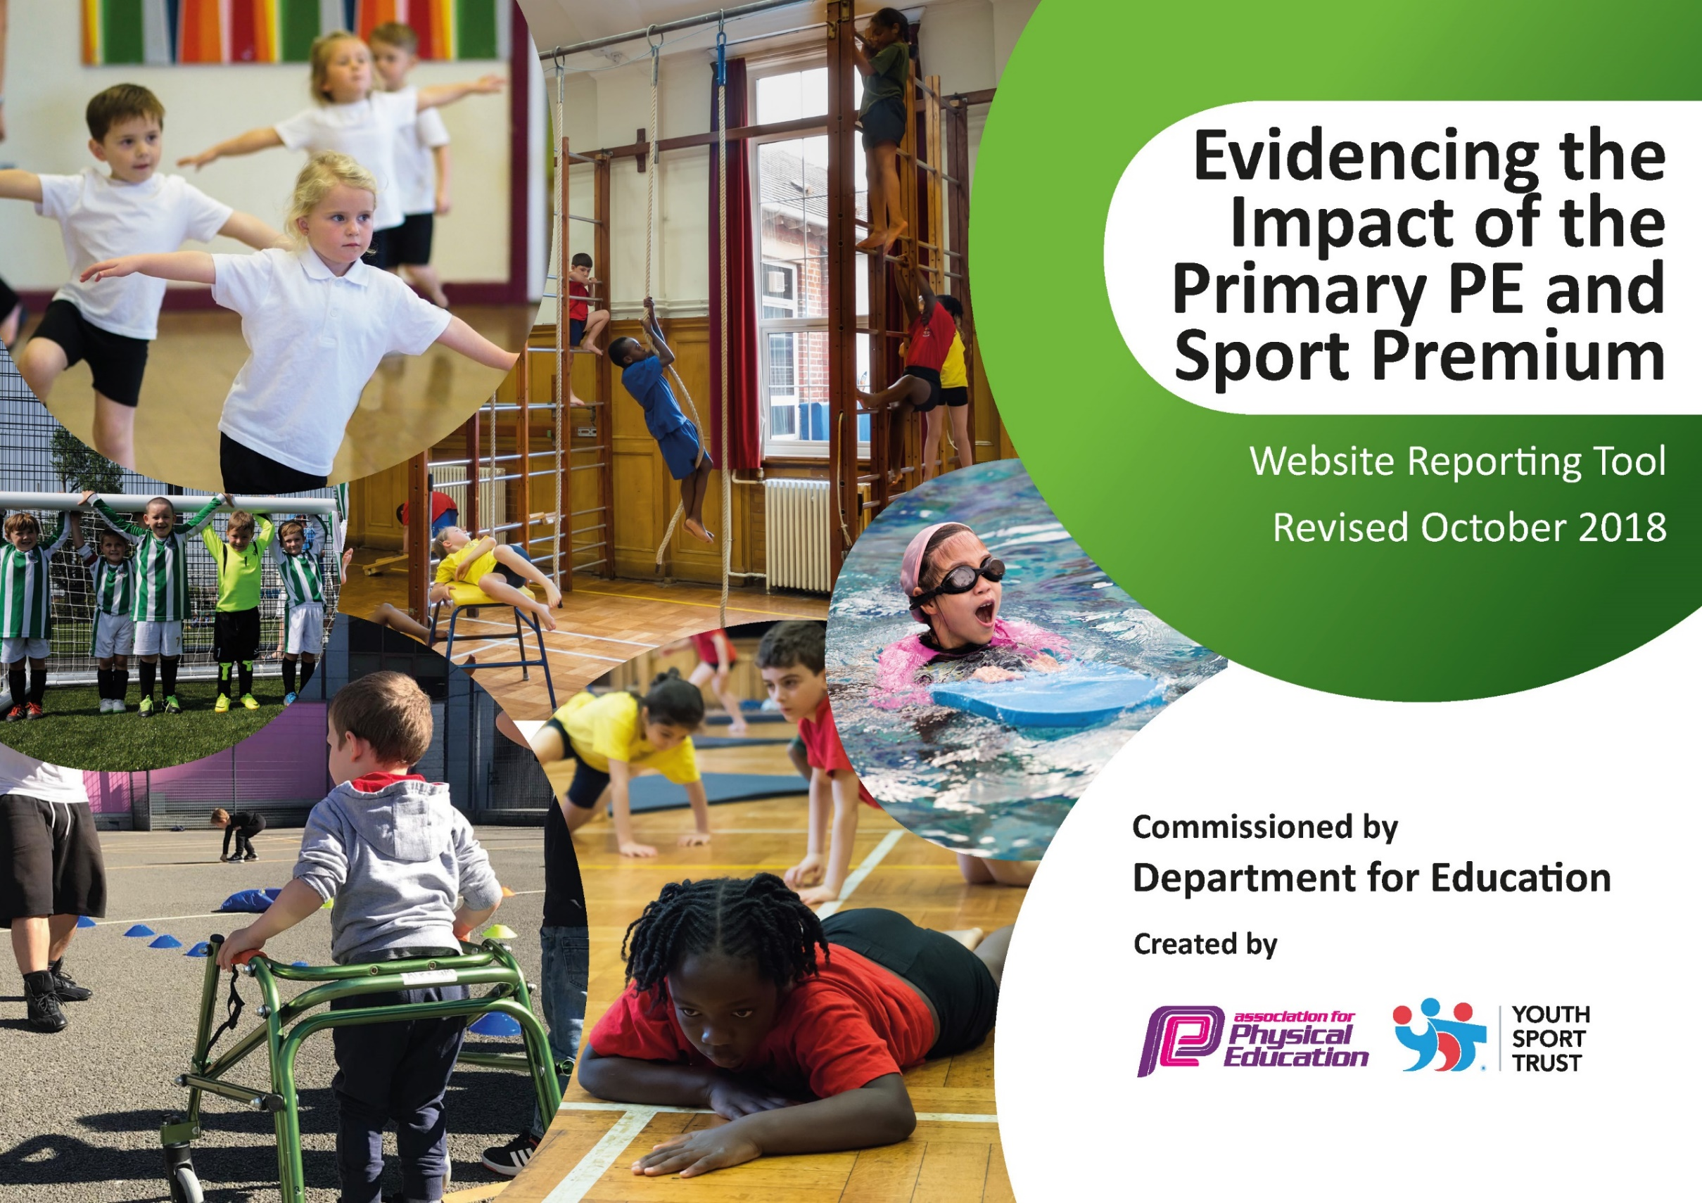
Mundella Primary School
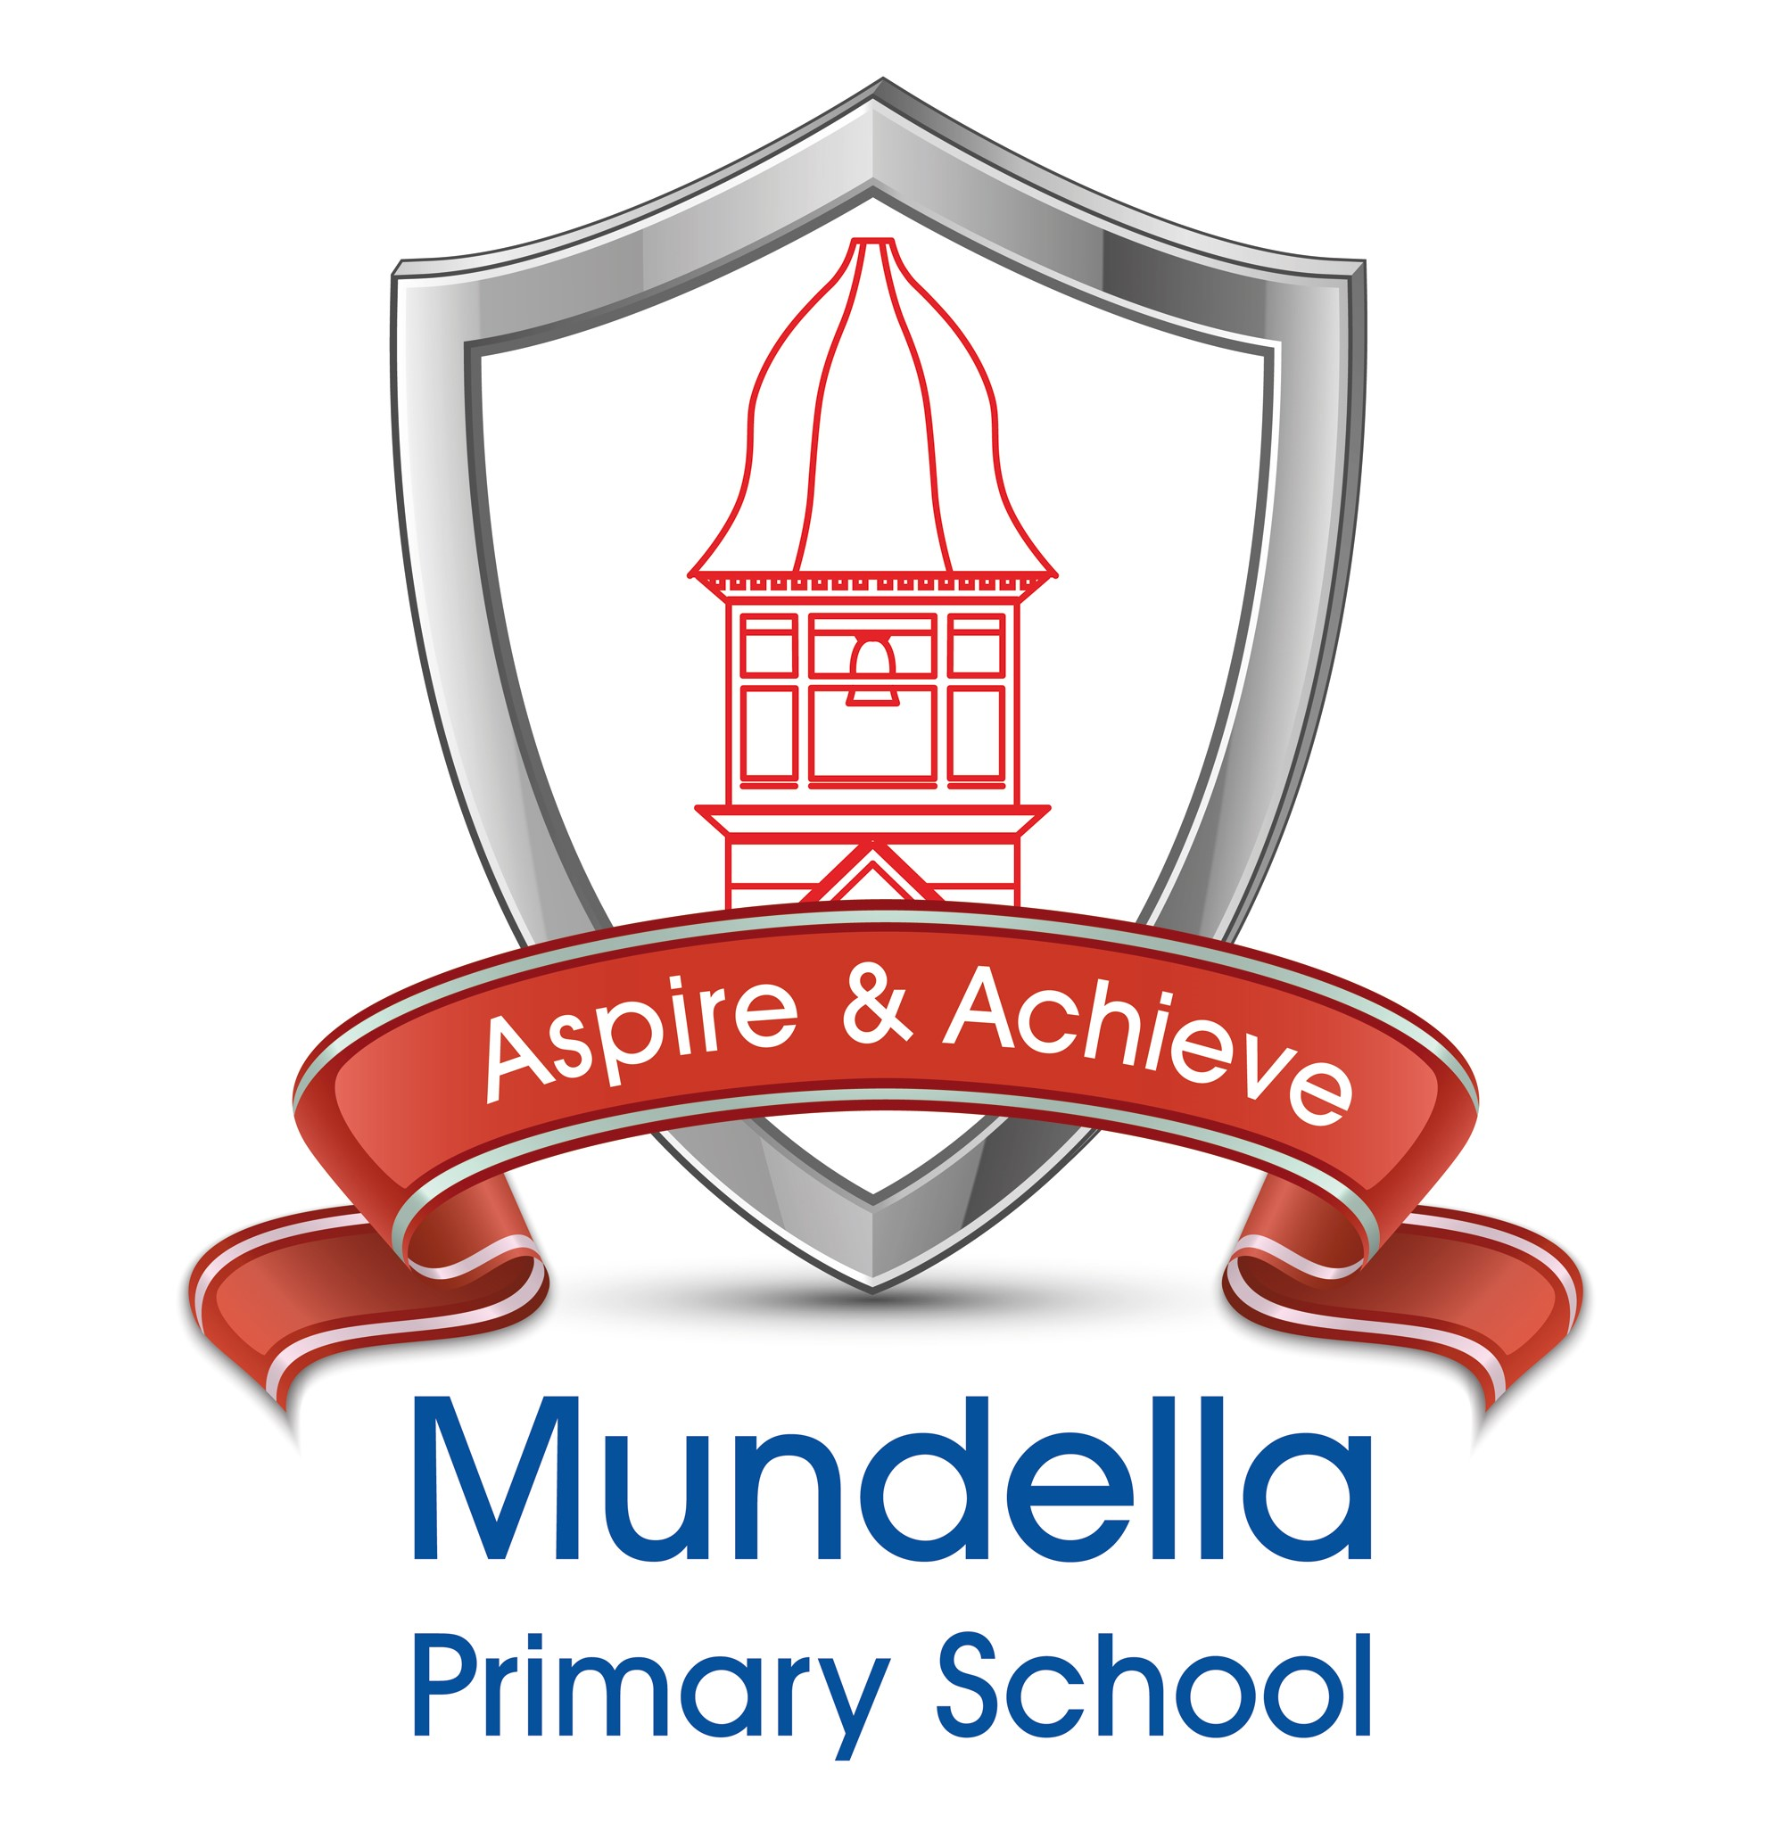
(updated 11-11-19)

Key achievements to date: | Areas for further improvement and baseline evidence of need:
- Increased school participation in area sports  - Upskilling pupils, across, the school, with high quality sports coaching  - Supporting healthy lifestyle and forming good habits through fruit project and Bagels  - Improved well-being knowledge through well-being package (Premier Sport)  - Improved outdoor space (playing surface) | - Increase number of sporting events attended  - Pupils actively using skills at other times  - Pupils sustained levels of activity have improved and they are choosing physical activities at break time  - Pupils are arriving early to eat fruit/bagels regularly  - Scans used to demonstrate engagement in activity  - Improved use of the school field (possible after school project)

Meeting national curriculum requirements for swimming and water safety | Please complete all of the below:
What percentage of your current Year 6 cohort swim competently, confidently and proficiently over a distance of at least 25 metres?  N.B. Even though our children may swim in another year, we report on their attainment upon leaving primary school. | 75%
What percentage of your current Year 6 cohort use a range of strokes effectively [for example, front crawl, backstroke and breaststroke]? | 75%  Focussing on one year group swimming has proven a significant success – up 25%
What percentage of your current Year 6 cohort perform safe self-rescue in different water-based situations? | ??%  (forms part of next assessment)
Schools can choose to use the Primary PE and Sport Premium to provide additional provision for swimming but this must be for activity over and above the national curriculum requirements. Have you used it in this way? | No

Academic Year: 2019/20 | Total fund allocated: £28,522 | Date Updated: 11-11-19
Key indicator 1: The engagement of all pupils in regular physical activity – Chief Medical Officer guidelines recommend that primary school children undertake at least 30 minutes of physical activity a day in school |  |  |  | Percentage of total allocation:
 |  |  |  | 10%
School focus with clarity on intended impact on pupils: | Actions to achieve: | Funding allocated: | Evidence and impact: | Sustainability and suggested next steps:
Enriched and more highly supervised break times with pm breaks introduced  Fitness opportunities increased | Training and support  Staff organisiation  Change to timetable  Pupils plan to skip x2 each week plus wake and shake at least once | £7000  (PS package £4265 to date)  £6000  (Additional specific equipment) | Few incidents of poor conduct or injuries  More engagement  Higher levels of physical activity  Pupils active and engaged forming better habits | Maintain level of staffing  Monitor engagement  Monitor equipment  Ensure equipment for all  Motivate staff to ensure done
Key indicator 2: The profile of PESSPA (Physical Education, School Sport and Physical Activity) is being raised across the school as a tool for whole school improvement |  |  |  | Percentage of total allocation:
 |  |  |  | 20%
School focus with clarity on intended impact on pupils: | Actions to achieve: | Funding allocated: | Evidence and impact: | Sustainability and suggested next steps:
Communicate importance across all stakeholders to raise profile and importance for good living and well-being  Improve playground and outside spaces | Regularly share and discuss with stakeholders as part of meetings and visits  Buildings and Maintenance plan reflects aspects | £7000  (PS package £4265 to date)  £6000  (Additional specific equipment) | PESSPA reflected in GMV notes, GB meeting minutes and minutes of other meetings  Plans and budget allocation for school environment | Ensure that PESSPA continues to develop and isn’t left off the agenda  Must see outside environment as part of med/long curriculum plan

Key indicator 3: Increased confidence, knowledge and skills of all staff in teaching PE and sport |  |  |  | Percentage of total allocation:
 |  |  |  | 40%
School focus with clarity on intended  impact on pupils: | Actions to achieve: | Funding  allocated: | Evidence and impact: | Sustainability and suggested  next steps:
‘Friend on Shoulder’ coaching model with staff observing, supporting and questioning | Staff to be active participants in all lessons and share feedback with other team members | £15,000  (SST Package £9510 to date) | Staff report back to phase teams and record notes in minutes | Continue to develop of staff driven CPD with team members saying what they put in and get out
Key indicator 4: Broader experience of a range of sports and activities offered to all pupils |  |  |  | Percentage of total allocation:
 |  |  |  | 20%
School focus with clarity on intended  impact on pupils: | Actions to achieve: | Funding  allocated: | Evidence and impact: | Sustainability and suggested  next steps:
Basketball, Archery, Multi-skills  (so far this year!) | Events, engagement and activity amongst a broader group of pupils than ever recently  New skills being developed | £15,000  (SST Package £9510 to date)  £7000  (PS package £4265 to date) | Events and levels of engagement and enthusiasm  Increased engagement in specific sporting clubs as a direct response | Commitment to repeat programme with additional school funding
Key indicator 5: Increased participation in competitive sport |  |  |  | Percentage of total allocation:
 |  |  |  | % incl. in other aspects
School focus with clarity on intended  impact on pupils: | Actions to achieve: | Funding  allocated: | Evidence and impact: | Sustainability and suggested  next steps:
Basketball, Archery, Multi-skills  (so far this year!) With pupils taking part in competitions and inter school events with transport package purchased | Teaching and learning for pupils with high quality coaches  Capacity to develop interests beyond school | £15,000  (SST Package £9510 to date)  £6000  (Additional specific equipment) | Events and levels of engagement and enthusiasm  Increased engagement in specific sporting clubs as a direct response | Commitment to repeat programme with additional school funding  Purchase some of the specialised equipment

