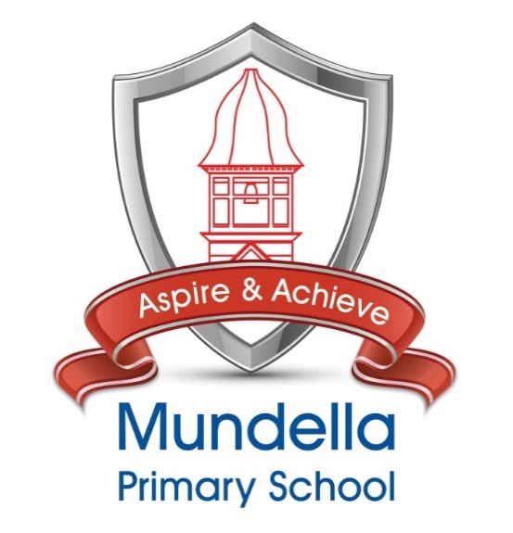
Assessment Policy
Including procedures for
Effective Marking and Feedback

Date of issue | Next review | Version | Signed: Chair of Governors | Signed: Headteacher
February 2023 | February 2025 | 1

Single Equality Statement
This Single Equality Scheme for schools in Mundella Primary School provides a format for addressing the statutory duties of the Equality Act 2010 and The Children and Families Act 2014. This supersedes and brings together all previous statutory duties in relation to race, gender and disability and also addresses the duty to promote community cohesion, thus meeting the school’s statutory duties in these areas.

Our Access and Single Equality Scheme is available to view and download on our website.
Governor Statement
The Governing Body of Mundella Primary School works as a ‘whole team’, meeting 6 times per year; spread evenly across the year, without any separate committees excepting finance. In addition to these meetings, we have termly Governor Monitoring Visits (GMV); usually lasting around four hours and organised to effectively observe, scrutinise, challenge and support a range of school activities and personnel.

An agenda for each meeting and GMV will include all the tasks which the governing body is required to consider, and the governing body will plan assignments or activities; arising from the business of the meeting or that fall into the annual monitoring schedule, which will be recorded in the minutes and then undertaken as directed.

In addition to ‘commissioning’ activities or actions on their behalf, the governing body may wish to delegate monitoring activities to ‘monitoring pairs’ or ‘individuals’. This could apply to statutory functions, and/or the priorities of the School Plan. They may also arrange to visit the school, or attend school activities, at any time; at the discretion of the Headteacher, to undertake monitoring activities as and when they are available to do so.

In each case, where a function has been delegated there is a statutory duty to report any action or decision to the governing body at the next meeting.

Rationale

Assessment is a continuous process, which is integral to teaching and learning allowing children to achieve their true potential. Assessment is seen as:
“the process of seeking and interpreting evidence for use by learners and their teachers to decide where the learners are in their learning, where they need to go and how best to get there” Assessment for Learning: Assessment Reform Group 2002

Aims
- To gather information about the performance of individual children, groups and cohorts in order to inform target setting and to monitor progress
- To provide information to inform the school’s strategic planning
- To identify gaps in learning to inform teachers’ planning
- To track individual, group and cohort progress
- To allow children to be involved in their own learning and evaluate their own achievements
- To inform the Governing Body of the school’s standards and achievement
- To celebrate the achievements of each child and enable next steps to be planned for effectively
- To identify learning difficulties quickly and efficiently to support provision of timely support
- To enable the systematic recording of overall achievements that can be easily shared with all stakeholders
- To allow easy access to data and information so the school and child’s achievements can be monitored both internally and by external visitors
- To meet the legal requirements for record keeping, assessing and reporting

Effective Assessment

At Mundella Primary School we believe effective assessment:

- Offers all children an opportunity to show what they know, understand and what they can do to improve
- Enables teachers to plan more effectively, thus supporting and challenging learners where required
- Enables parents to become fully involved in their children’s learning and progress
- Provides the school with information with which to evaluate work and set suitable targets

Types of Assessment at Mundella Primary School

Day to day in school formative assessment

Formative assessment underpins our curriculum and ensures that pupils master the curriculum we teach. It takes place on a daily basis and is integral to teaching and learning. Learning outcomes are shared with pupils and teachers discuss with pupils how learning outcomes can be achieved.
Examples of formative assessment used at Mundella:

- Asking a range of questions in a variety of ways
- Self and peer assessment
- Marking of pupils’ work
- Oral feedback or dialogue between adults and pupils.
- Observational assessment
- Regular short re-cap quizzes/learning checks
- Scanning work for pupil attainment and development

In-school summative assessments

- End of year tests
- Regular formal tests
- Reviews for pupils with SEN and disabilities
- Learning over time in books

There is a clear assessment overview which outlines any testing/assessments that are to be completed at any given time. It is important that a child is being tested with an appropriate test suitable for their age range and ability. Where tests are not age appropriate this is clearly recorded so this information is passed onto the next teacher. If a pupil has a scribe, reader, extra time etc, this is also clearly documented. The Monitoring Timetable and School Calendar is updated annually and this sets out when data is collected across the year.

End of year targets are set for each pupil at the beginning of Term 1. We currently collect which step on Sonar each child is on at the end of Term 1, 2, 3, 4, 5 and 6. This data will be entered into Sonar and used to track pupil’s achievement in terms of how they have attained and how they are progressing. We recognise that learning is not linear and pupils will peak and plateau at various points throughout their education at Mundella. SMT and phase leaders use the data on Sonar to analysis progress of intervention groups, individuals and cohorts of children to set targets and monitor progress and age related expectations. Through quality teaching, robust tracking and professional dialogue, (including pupil progress meetings) we will endeavour to ensure that all children are given the support and challenge they need.
Pupil progress meetings occur termly throughout the year, led by the Senior Leadership Team, and also through professional dialogue during Staff Meetings and PPA.

Nationally Assessments:

- EYFS Baseline Assessment
- Phonics Screener at the end of Year 1
- Phonics Screener retake at end of Year 2
- National Curriculum teacher assessments at the end of Key Stage 1
- Multiplication Tables Check at the end of Year 4
- National Curriculum tests (SATs) at the end of Key Stage 2

The SENCO, in conjunction with class teachers and parents, coordinates access arrangements for nationally standardised assessments, alongside the Kent Test.

SLT analyse Key Stage results and identify gaps. Analysis is reported to the Headteacher, Governing Body and CEO. Findings are incorporated into the School Plan.

Reports to Parents

Reports are sent to parents at the end of each term. Colour coding shows levels of progress, attainment and attitude to learning in in Reading, Writing and Maths. Homework, reading at home, punctuality, uniform and attendance are also reported on with a colour code. The report sent out in term 6 also includes subject comments and information related to end of Key Stage Test results and Year 1 phonics or Year 2 retake results.

When reporting to parents, we aim to be factual, specific and refer to past learning. We try to be positive about achievement and point the way to any future learning objective. We reflect the importance of the child in the process so the report can be understood by the child at an appropriate level. Pupil attendance is also reported to parents on every interim report.

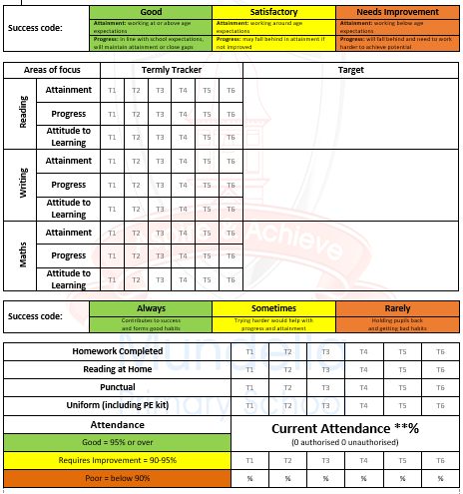

Parent Consultation Meetings

Parent Consultation Meetings take place three times during the school year, in the autumn, spring and summer terms. During these meeting teachers discuss the child’s progress and share targets or areas for development that the child needs to work on. Teachers are also available for informal consultation after school throughout the year.

Effective Marking and Feedback

Rationale

Mundella Primary School believes that marking and feedback of children’s work has three basic functions:

- To help children’s learning move on by providing them with developmental feedback that can be responded to and the subsequent progress monitored.

- To celebrate children’s achievements and let them know when they have done well in relation to learning objectives and success criteria.

- For both children and teachers it must be: Meaningful, Manageable and Motivating.
(DFE, 26.3.16 from marking policy review Group report’)
Where pupils have grappled with their learning, learnt from mistakes and have demonstrated a growth mind-set; recognition of this is paramount to ensure we are developing learners well. Marking and feedback will enable pupils to become reflective learners and help them to close the gap between current and desired outcome. All pupils are entitled to receive effective feedback and to have their learning marked in accordance with this policy. It will be accessible for all pupils and will reflect their individual needs and abilities.
This policy supports all forms of marking and feedback within the process of teaching and learning. This includes: verbal feedback, written feedback, peer/collaborative marking and self-evaluation.
Aims

Marking and feedback should:
- Be made throughout the lesson to reflect on learning where possible.
- Relate to learning objectives and success criteria which have been shared with pupils.
- Challenge pupils of abilities and support pupil improvement.
- Give recognition and praise for achievements.
- Give clear strategies for improvement.
- Allow specific time for pupils to read, reflect and respond to feedback and make improvements during the lesson.
- Respond to individual learning needs. This will sometimes be done in the presence of the child and other times in the absence of the child.
- Identify gaps in children’s learning to inform future planning.
- Promote accuracy of key writing and number skills.
- Be accessible to all pupils and appropriate for age/stage of development.
- Be seen by the pupils as positive in improving their learning.
- Be manageable for teachers.
- Be a two way communication between the pupils and the class teacher.

Responsibility

- It is the responsibility of the class teachers to ensure that this policy is carried out.

- Each phase leader has got the responsibility for checking that the policy is being carried out.

- It is the responsibility of the Assessment Leader to collect evidence from Phase Leaders and to feedback to the Headteacher and Governors on the implementation of this policy.

- As part of the monitoring cycle and through staff training, the quality of marking and feedback in books will be regularly looked at.

Implementation

When marking or giving feedback teachers need to consider:

- Does it relate to planned learning objectives and success criteria or targets?
- Can it be read clearly and understood?
- Have they indicated a next step in learning?
- Have they encouraged independence appropriate for age and stage of development?

- When marking teachers should use a neat, legible style of handwriting that models our school handwriting policy.

- Adults use a green highlighter to identify positive aspects of the learning.

- Adults use an orange highlighter to identify areas for improvement within the work.

- Blue pens are used by adults to make comments on the child’s learning.

- Pupils respond to marking and edit their work or their partner’s work in green pen.
- Any requests for consultation are followed up with a child and any misconceptions/difficulties are addressed.

- Remember wrong answers in books can show appropriate challenge and that making mistakes is where good learning can occur. It is not the expectation that every piece of work is correct.

- A list of marking codes used within the school will be displayed in the classroom and all children should have access to the codes.
Marking Codes and Formats

Learning outcomes (LO) are shared with pupils and teachers discuss with pupils how learning outcomes can be achieved.

Verbal Feedback (VF) as with all marking strategies it will consist of assessment against the learning objective to extend, support or challenge the learners thinking throughout the lesson. Where verbal feedback is given, the code VF will be written in the child’s book.
Peer-Assessment (PA) Time and training must be given to encourage the use of response partners. Peer assessment in books will be completed in green pen with the child’s name.
Self-Assessment (SA) The pupils are expected to self- assess their work during the lesson and to make improvements against the LO and SC using green pen.

Distance Marking is most effective when marking in depth and may involve the use of full comments that are developmental. If these are to be used they will fall into three main categories:
- A reminder prompt e.g. What else could you say about the boy?
- A scaffolded prompt e.g. ‘What was the dog’s tail doing?’ The dog was so angry he...’, ‘describe the expression on the dog’s face’.
- An example prompt e.g. Choose one of these or your own: He ran around in circles looking for the rabbit/The dog couldn’t believe his eyes’).
When work has been distanced marked, time should be given for children to read and then make a focused improvement based on the improvement suggestion. In order for the marking to be formative, the information must be used and acted on by the children in green pen.

Spelling and Grammar

Promoting English skills across the curriculum is essential in developing each child’s key writing skills and spoken English. In addition to marking linked to the desired Learning Objective, key writing skills may also be commented on to further develop accuracy.

Maths

Children should be encouraged to use correct number formation and this should be corrected or the child should be encouraged to correct it where possible. Children should receive feedback in line with our calculation policy and in particular where pupils have clearly shown their Mathematical thinking and reasoning.

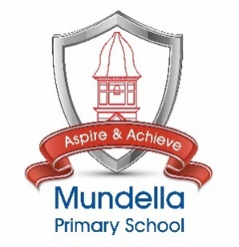
Mundella Marking Codes

English & Topic

VF | Verbal Feedback
SP | Spelling Review
P | Punctuation Review
// | New Paragraph
SA | Self-Assessment
PA | Peer-Assessment
^ | Missing Word / Phrase
 | Next Steps

Maths

. | Take another look
✓ | Correct
 | Next Steps

